**Research & Development Project**

**B.Sc. in Digital Medical Technologies**

**Anomaly Detection in Operating Room Performance Metrics and Development of a Bed Occupancy Prediction Model**



**Students:**  Dvora Goncharok, 322336603 and Arbel Shifman, 207835562

**Academic Supervisor:** Prof. Aviv Gibali, Dr. Yariv Marmor



**Signatures:**

**Clinical\Industrial** **Supervisor:** Dr. Royi Barnea

**Date of submission: 31/07/2025**

Table of Content

**Project proposal form** 2

**Project Abstract** 3

**Abbreviation** 17

**Introduction** 18

**Theoretical background** 19

**Literature Review** 19

**Research Question** 23

**Project planning and execution** 27

**Analysis of literature review** 27

**Methodology** 29

**Data Preparation and Exploratory Data Analysis (EDA)** 29

**Development of Daily Utilization Rate** 30

**Problems Encountered and Solutions** 30

**Predictive Modeling of Surgery Duration** 31

**Data Preparation and Feature Engineering** 31,37

**Expected outcomes** 39

**Project Results** 40

**Overview** 40

**Predictive Modeling of Surgery Duration** 50

**Discussion** 82

**Summary of System Development and Execution** 86

**Recommendations for Future Development** 86

**Final Conclusions** 87

**Conclusions** 88

**Further research and development** 88

**Summary of project activities** 89

**Project Summery** 90

**List of Illustrations/Figures** 91

**List of Tables** 92

**Bibliography** 94

**Appendix**. 96

Project proposal form

**Department of Digital Medical Technologies**

**Holon Institute of Technology HIT (41111)**

**Attention! The form must be filled out digitally. Do not change the form structure.**

A scanned form or one with missing details will not be accepted.

The Project proposal will be submitted up to one month after the project starting day (see moodle for exact date on submission)

The proposal serves as the basis for project research and development process and must include Tasks, milestones and deliverables

|  |  |  |  |
| --- | --- | --- | --- |
| **Hebrew Year** | | | |
| **ה** | **פ** | **ש** | **ת** |

**Semesters 1+2**

**Semesters 2+Summer**

**Date of submission (student):**22 .**12.2024**

1. **Student details:**

|  |  |  |  |  |
| --- | --- | --- | --- | --- |
| **Full Name** | **Dvora Goncharok** |  | **Full Name** | **Arbel Shifman** |
| **ID number** | **322336603** |  | **ID number** | **207835562** |
| **Phone** | **0507156024** |  | **Phone** | **0526413312** |
| **E-Mail** | **dvoragon@gmail.com** |  | **E-Mail** | |  |  | | --- | --- | | **arbelsh1998@gmail.com‬** | | |  |  | |





 **Student signature Student signature**

1. **Project Name:**

**Anomaly Detection in Operating Room Performance Metrics and Development of a Bed Occupancy Prediction Model.**

1. **Supervisor's names:**

**Academic supervisor: Prof. Aviv Gibali, Head of Applied Mathematics Department and Dr. Yariv Marmor, Senior Lecturer, Department of Industrial Engineering and Management in Braude Academic College of Engineering, Karmiel.**

**External (clinical\industrial) supervisor: Dr. Royi Barnea, Principal Investigator, Assuta Institute for Health Services Research.**

1. **Background and rationale for the project, description** **of the problem**

**Please describe: (1) The background and rationale of the project. (2) Define the problem-what is the challenge the project will address, (3) the Aim of the project.**

*This section should contain at least 10 lines (note: background is neither the purpose of the project nor the description of the project).*

|  |
| --- |
| One of the main challenges in hospitals today is the availability of surgical appointments. Patients expect fast and efficient treatment, but delays and long waiting times often lead to frustration. At Assuta Ramat HaHayal, which operates as a private hospital, there are17 operating rooms. The scheduling system is based on time blocks allocated to each surgeon, which means that if there’s an unexpected no-show or cancellation, valuable operating time might go unused. Filling these gaps isn’t simple because calling another patient last-minute often requires preparation that can’t always be done on the spot.  Another issue lies with hospital beds: recovery room beds and inpatient beds, which are essential for post-surgery recovery. Inpatient rooms have two beds per room and no hallway beds, limiting the number of surgeries that can be scheduled. This causes delays, as the patient "occupies a bed" while waiting to be transferred to the recovery room. Consequently, an operating room cannot be cleaned and prepared for next patient. Without a guaranteed bed, surgeries must be postponed, creating a bottleneck in the system.  In private hospitals like Assuta, the financial model depends on revenue from patients, often through insurance companies, rather than government funding like in public hospitals. Losing patients as clients because of long waiting times or inefficient management has a direct financial impact. Patients who experience delays may choose other hospitals with shorter wait times, which means lost revenue and missed opportunities to meet patient care goals.  This project aims to tackle these issues by analyzing the current scheduling and operational practices to identify bottlenecks, such as underused surgery time slots or recovery and hospitalization bed shortages. It will also explore ways to optimize patient flow, improve scheduling, and ensure better use of resources. Ultimately, the goal is to reduce waiting times, improve patient satisfaction, and help the hospital meet its financial and operational targets without compromising on the quality of care. |

1. **Project Goals and expected outcomes**

**Define the specific goals you plan to achieve in this project**

|  |
| --- |
| The primary goal of this project is to improve the utilization of operating rooms at Assuta Ramat HaHayal. This includes minimizing unused time slots, ensuring a fully booked surgical schedule, avoiding unexpected gaps, and implementing a more effective queue management system. The aim is to create a smoother, more predictable surgical day that maximizes resources without compromising patient care or safety.  One of the key metrics for evaluating operating room efficiency is daily **utilization rate** ($ρ)$, calculated as follows: $$ρ=\frac{\sum_{r}{\sum_{p}{{SU}_{p}+\tilde{S_{p}}}}}{\sum_{r}{SH_{r}}}$$ where ${SU}_{p}$ is the set-up time of patient $p$ in the room $r$, $\tilde{S_{p}}$ is the surgery duration within the shift length and $SH_{r}$ is the shift length of room $r$.  The Utilization Rate measures how much the operating room is occupied, including anesthesia, preparation and stitching, compared to the total available hours.  Currently, the utilization rate is around 80-82%, but it should not exceed 89%, as going beyond this threshold negatively impacts both the quality of treatment for patients and the performance of surgeons. Overloading the system can also compromise safety standards.  In addition to this metric, a combination of other variables will be explored in later stages to further optimize the process. As part of the solution, we aim to develop a **dynamic prediction model** that considers inpatient bed occupancy and factors such as patient age, underlying health conditions, and other variables that may extend surgery or recovery time. This model will provide accurate predictions of bed availability and surgical timelines.  The final deliverable of the project will be a **visual dashboard** that offers a clear and actionable overview of bed availability, surgical efficiency, and potential scheduling solutions for addressing issues such as "no-shows" for surgeries. This tool will help optimize bed occupancy and improve overall resource management.  The prediction model is expected to forecast inpatient bed occupancy 5-7 days in advance, allowing better planning and scheduling of surgeries. The proposed solution will be tailored for all hospital departments at Assuta Ramat HaHayal, focusing on the unique needs of each discipline. By considering the specific characteristics of different departments, the solution will ensure optimal and department-specific outcomes. |

1. **The Proposed solution; methods and performance indicators**

**What is the proposed solution? Please explain how you will achieve the project goals. Please provide detailed** **methods and performance indicators in which the project will be evaluated, to ensure that the project successfully met the goals**

|  |
| --- |
| The proposed solution focuses on improving operating room utilization and developing a dynamic prediction model for inpatient bed occupancy. To achieve this, we will implement a combination of data-driven methods and performance metrics to monitor, predict, and optimize hospital resources. The solution includes real-time surgical monitoring, anomaly detection, and the identification of trends to enhance decision-making processes.  **Methods and Proposed Steps:**   1. **Analysis of Length of Stay (LOS):** We will improve the forecast of LOS by reducing the variance for each patient to identify unexpected patterns, such as prolonged hospital stays. Anomalies in LOS may indicate inefficiencies in treatment or resource allocation. By addressing these inefficiencies, we can improve bed turnover and ensure better resource availability. 2. **Monitoring Hospital-Acquired Infection Rates:** Tracking infection rates will provide insights into patient safety and care quality. High infection rates often result in extended LOS, reducing bed availability. By identifying and mitigating these risks, we aim to improve overall hospital efficiency. 3. **Integration of Patient Safety Indicators (PSI):** We will use PSI, developed by AHRQ, to identify safety events like postoperative complications or adverse drug reactions. Addressing these issues will enhance care quality and reduce unexpected delays in patient discharge. 4. **Optimization of Turnover Time:** Turnover time, the duration required to prepare the operating room between surgeries, will be monitored and optimized. Reducing this time will allow for more surgeries within the same operating hours, improving utilization rates without compromising safety by using data mining and machine learning methods in order to predict bed occupancy time and track bed turnover, and by mining data we can learn about relationships in the data and trends that cause LOS to be extended. 5. **Dynamic Prediction Model for Bed Occupancy:** Using big data analysis tools, we will develop a dynamic prediction model capable of forecasting inpatient bed occupancy 5-7 days in advance by using computational methods. This model will incorporate variables such as patient demographics, comorbidities, and surgery types to provide accurate predictions and improve scheduling. 6. **Identification of Anomalies and Trends in Data:** Through database analysis, we will identify key metrics and outliers, enabling better understanding and management of resources. By detecting trends, we can make proactive adjustments to improve operating room efficiency and optimize bed usage.   **Expected Deliverables:**   1. **Improved Utilization Rates:** By addressing inefficiencies and enhancing data-driven decision-making, the proposed solution aims to increase operating room utilization to an optimal level (between 81-89%) and improve inpatient bed turnover. 2. **Real-Time Monitoring Dashboard:** A visual dashboard will display real-time metrics, including LOS, infection rates, turnover time and bed availability. This tool will help hospital staff make informed decisions and quickly respond to unexpected situations. 3. **Predictive Model and Insights:** The prediction model will allow hospital management to anticipate resource needs, such as bed availability, and schedule surgeries accordingly. It will be tailored to the specific needs of each department within Assuta Ramat HaHayal, considering the unique characteristics of different disciplines.   **Performance Indicators:**   * Improved operating room utilization within safe limits (81-89%) by optimizing surgeons' time blocks, reducing unused gaps, and improving scheduling efficiency to minimize cancellations. * Observe better performance accuracy in average LOS when implementing the model. * Reduction in turnover bedtime. * Decrease in hospital-acquired infection rates. * Improved forecast accuracy for bed occupancy (measured in days). |

1. **The research and development plan**

**List the main tasks to achieve the goals of project.**

|  |
| --- |
| **Research and Development Plan**   1. **Data Collection, Preprocessing, and Visualization:**   Before performing analysis and building predictive models, we will first collect andpreprocess the data, including handling missing or outlier values (EDA). We will then create visualizations to identify patterns and trends in the data, which will help in understanding key insights and preparing the data for accurate forecasting.  To forecast surgical duration, we will use statistical and machine learning techniques, starting with exploratory data analysis (EDA) using Python libraries like Pandas and Matplotlib to identify patterns and trends in the data. Based on the data structure and availability, we plan to implement regression models, such as Linear Regression or Decision Trees, using Scikit-learn to predict surgery durations. These models will incorporate variables such as patient demographics, surgery type, and historical trends.  The model's performance will be evaluated using metrics like Mean Absolute Error (MAE) and R-squared (R²), and cross-validation techniques will be applied to ensure robustness. For handling uncertainty and variability in predictions, we will consider robust optimization methods to improve scheduling efficiency. For further validation and testing, libraries like NumPy and SciPy will be utilized to fine-tune the model and improve accuracy.   1. **Analyzing Existing Trends in Operating Rooms by analyzing the database:**  We will perform database analysis to evaluate surgical duration, inpatient length of stay (LOS), operating room utilization, and turnover numbers as key outcome measures. Additionally, we will identify and compare trends across different departments in the Assuta network, including orthopedics, gynecology, ENT, and others. These findings will be used to highlight operational efficiencies and discrepancies specific to each medical discipline. 2. **Developing a Predictive Model for Bed Occupancy (5 Days in Advance) by tools for analyzing big data:**   We will utilize advanced big data analysis tools to create a predictive model for inpatient bed occupancy based on the scheduled surgical plans. The model will incorporate variables such as the type and duration of surgeries, as well as department-specific characteristics, to ensure accurate forecasting. These insights will help optimize bed allocation and improve surgical scheduling efficiency. |

1. **References** 
   1. Abbou, B., Tal, O., Frenkel, G., Rubin, R., & Rappoport, N. (2022). Optimizing operation room utilization- A prediction model. *Big Data and Cognitive Computing, 6*(3), 76. <https://doi.org/10.3390/bdcc6030076>
   2. Bou Saleh, B., Bou Saleh, G., & Barakat, O. (2020). Operating theater management system: Block scheduling. In *Artificial intelligence and data mining in healthcare* (pp. 83–98). Springer. <https://doi.org/10.1007/978-3-030-45240-7_5>
   3. Marmor, Y. N., Rohleder, T. R., Huschka, T., Cook, D., & Thompson, J. (2011). A simulation tool to support recovery bed planning for surgical patients. *Proceedings of the 2011 Winter Simulation Conference*, 1338–1344. <https://citeseerx.ist.psu.edu/document?repid=rep1&type=pdf&doi=16ba94de21edc49d85136d465c6fb15719a80bb8>
   4. Seo, H., Ahn, I., Gwon, H., Kang, H., Kim, Y., Choi, H., ... & Kim, Y.-H. (2024). Forecasting hospital room and ward occupancy using static and dynamic information concurrently: Retrospective single-center cohort study. *JMIR Medical Informatics, 12*, e53400. <https://doi.org/10.2196/53400>
   5. Tyler, D. C., Pasquariello, C. A., & Chen, C.-H. (2003). Determining optimum operating room utilization. *Anesthesia & Analgesia, 96*(4), 1114–1121. <https://doi.org/10.1213/01.ANE.0000050561.41552.A6>
2. **Risk analysis table**

**List main tasks as well as development risks (if any) and how you will overcome these risks**

| **Description of risk (Severity: Minor, Severe, Critical; Likelihood: Low/Medium/High)** | **Proposed risk-mitigation measures** |
| --- | --- |
| **Data quality issues: Missing or incomplete data from hospital records (Severity: Severe; Likelihood: Medium)** | **Conduct thorough data validation and cleaning processes. Implement algorithms to handle missing data (e.g., imputation methods).** |
| **Model accuracy: Predictive model may not achieve high accuracy due to insufficient training data, or overfitting the model to the data (Severity: Severe; Likelihood: Medium)** | **Collect additional data and use advanced machine learning techniques. Validate the model with cross-validation and external datasets.** |
| **It is difficult to increase utilization without adding new beds under the constraints of adjacent waiting times for surgery and the restrictions discussed in the previous sections. (Severity: Severe; Likelihood: Medium)** | * **Prolonged setup times between surgeries:**   **Use a Linear Programming optimization algorithm to group surgeries requiring similar equipment and preparation, minimizing transition/setup times.**   * **Idle time caused by suboptimal scheduling: Develop a predictive model using historical data (e.g., surgery duration, equipment needs) to optimize scheduling and fill idle gaps with shorter procedures.** * **Variability in surgery durations: Implement Random Forest Regression to accurately predict surgery durations, accounting for procedure type, equipment, and team experience.** |
| **Resistance to change: Staff may be reluctant to adopt new tools and workflows (Severity: Minor; Likelihood: High)** | **Provide training sessions and clear documentation. Highlight benefits of the system to encourage adoption.** |

|  |  |  |  |  |
| --- | --- | --- | --- | --- |
| **Name of academic supervisor** |  | **Date** |  | **Signature** |
| **Prof. Aviv Gibali** |  | **22/12/24** |  |  |
| **Dr. Yariv Marmor** |  | **22/12/2024** |  |  |

**Gantt Project Activities**

**This table will be updated during the project by the student(s) according to the development of the project,**

**Both the students and the supervisor will hold a copy of this table**

**\*\* The student must complete two additional milestones according to the nature of the project and in coordination with the supervisor,**

**for example: learning the platforms, developing a prototype**, **submitting for testing by stages,** **etc.**

|  |  | **Month** | | | | | | | | |
| --- | --- | --- | --- | --- | --- | --- | --- | --- | --- | --- |
| **Task** | **Detail / Format** | **Milestone** | **1** | **2** | **3** | **4** | **5** | **6** | **7** | **8** |
| **Project proposal form, submitted** | **PDF file and Word file.** | **1** | **X** |  |  |  |  |  |  |  |
| **Data collection** | **Collect data from the hospital's records.** |  | **X** | **X** | **X** |  |  |  |  |  |
| **Data Cleaning, and Preparation (Basic EDA):**   * **Organize and clean the data to make it ready for analysis.** * **Find trends and key metrics to identify areas for improvement.** | **Python code:**   * **Handle missing values and outliers.** * **Organize the data into a structured format.** * **Create simple visualizations to identify initial patterns.**   **Format: clean dataset in CSV format and a short report (Word/PDF).**  **Analyzing Trends and Patterns (Advanced EDA):**   * **Analyze surgery durations, inpatient length of stay (LOS), and operating room utilization.** * **Identify patterns and trends across different departments (e.g., orthopedics, gynecology).** * **Highlight inefficiencies, such as long waiting times or underutilized operating rooms.**   **Format: Report of the visualizations (Word/PDF).** |  | **X** | **X** | **X** |  |  |  |  |  |
| **Building a Model to Predict Surgery Duration**   * **Develop a model to predict surgery durations based on patient and surgery data.** | **Python code:**   * **ML methods like Linear Regression or Decision Trees.** * **Evaluate model performance with metrics like MAE and R².** * **Apply cross-validation and optimize the model for better accuracy.**   **Format: Python script along with a summary of results in Word/PDF.** |  |  | **X** | **X** | **X** | **X** | **X** |  |  |
| **Submitting an Interim Report** | **PDF file and Word file.**  **will be submitted by the supervisor according to the submission date indicated in the box found on Moodle** | **2** |  |  | **X** |  |  |  |  |  |
| **Developing a Predictive Model for Bed Occupancy (5 Days in Advance)**   * **Build a dynamic model to forecast inpatient bed usage to improve scheduling.** | **Python code:**   * **big data tools to predict bed occupancy based on surgery plans.** * **Variables like surgery type, duration, and department characteristics.** * **Predictions to optimize resource allocation.**   **Format: Python script with the model, along with a report in Word/PDF.** |  |  |  |  | **X** | **X** | **X** |  |  |

| **Real-Time Dashboard**   * **Develop a dashboard to display live data for better decision-making.** | **Dashboard in Power BI:**   * **Include key metrics like surgery times, bed availability, and infection rates.** * **Integrate the predictive models into the dashboard.** * **Allow interactive use for quick adjustments based on real-time data.** |  |  |  |  | **X** | **X** | **X** | **X** |  |
| --- | --- | --- | --- | --- | --- | --- | --- | --- | --- | --- |
| **Project book submission and results** | * **Project Book** * **Project Poster** * **Project video** * **The product (algorithm/code/predictive model/software/ article)** | **3** |  |  |  |  |  |  | **X** |  |
| **Oral Exam** | * **Oral-Exam Presentation** | **4** |  |  |  |  |  |  |  | **X** |

Project Abstract

Hospitals face significant operational challenges, particularly in surgical scheduling and bed allocation. Assuta Ramat HaHayal, a private hospital with 17 operating rooms, frequently encounters inefficiencies such as cancellations, delays, and underutilized resources, leading to patient dissatisfaction and financial losses. The primary goal of this project was to improve the utilization of operating rooms and inpatient bed management through advanced data-driven methods.

We developed two robust predictive machine learning models: a CatBoost regression model to accurately forecast individual surgery durations and a BiLSTM-based time-series model to predict inpatient bed occupancy at a departmental level up to seven days ahead. The CatBoost model demonstrated excellent predictive performance with cross-validation results showing mean absolute errors (MAE) of approximately 19–21 minutes, significantly improving over traditional scheduling methods. Key variables influencing these predictions included surgical activity codes, team size, surgeon workload, and patient demographics.

The bed occupancy prediction model showed moderate accuracy, with performance varying across departments. Departments such as Urology & ENT, Orthopedics & Neurosurgery, and General Surgery achieved practical forecasting accuracies (R² ranging from 0.41–0.57). However, departments such as Cardiothoracic Surgery and Internal Medicine/Oncology displayed lower predictive accuracy due to structural data limitations and patient flow complexity. We addressed these issues by refining the dataset, excluding systematically incomplete data (2023–2024), and engineering multiple time-based and clinical features.

Additionally, we developed a multi-stage optimization framework for surgical scheduling, integrating heuristic methods, constraint programming (CP), and mixed-integer linear programming (MILP). The optimization model aims to maximize operating room utilization while adhering to real-world constraints such as staff availability and room capacities. As part of this effort, we constructed a dedicated daily utilization DataFrame, aggregating actual surgery durations per room and per date. This allowed us to calculate the percentage of time each operating room was actively used relative to its available scheduling blocks- providing a reliable metric to evaluate efficiency gains from the optimized schedules.

To assess the real-world impact of our optimization framework, we applied the CP-based scheduling model in a rolling horizon fashion over one full month of real surgical data. This dynamic weekly approach simulated realistic hospital planning workflows, incorporating up-to-date resource availabilities and clinical constraints.

Despite computational limitations, the model produced a marked improvement in operating room utilization. On average, historical utilization across room-day combinations stood at 28.4%, while our optimized schedules achieved 57.2% utilization- effectively doubling the efficiency of resource use. Notably, in over 80% of the cases, the model outperformed historical scheduling, with many individual room-day combinations showing improvements of 60 to 80 percentage points.

These findings were supported by visual comparisons, including scatter plots and utilization distributions- that clearly demonstrated the added value of our approach. Beyond numeric gains, the model proved robust, adaptable, and ready for integration into real hospital workflows, validating its practical potential to enhance operational planning and resource management at Assuta.

All predictive and optimization models were integrated into an interactive Power BI dashboard designed for real-time decision support. This tool provides hospital managers and operational staff actionable insights, enabling proactive management of surgical schedules and bed occupancy.

Overall, the project successfully delivered validated machine learning models trained on the full dataset, alongside an advanced optimization framework. While the predictive models were evaluated across the entire surgical and hospitalization history, the optimization framework was applied in a rolling-horizon simulation over a full month of real surgical data. Together, these components significantly enhanced Assuta Ramat HaHayal’s operational capabilities. The integrated system demonstrated clear value in improving scheduling efficiency, resource utilization, and patient care- marking a substantial advancement in the hospital’s data-driven decision-making and operational management.

Abbreviation

|  |  |
| --- | --- |
| OR | Operating Room |
| LOS | Length of Stay |
| ICU | Intensive Care Unit |
| CP | Constraint Programming |
| MILP | Mixed-Integer Linear Programming |
| OR-Tools | Operations Research Tools (Google Optimization Library) |
| CP | Constraint Programming |
| BiLSTM | Bidirectional Long Short-Term Memory |
| MAE | Mean Absolute Error |
| R² | Coefficient of Determination |
| EDA | Exploratory Data Analysis |
| DF | DataFrame |
| KPI | Key Performance Indicator |
| ENT | Ear, Nose and Throat |
| CRNA | Certified Registered Nurse Anesthetist |
| PACU | Post-Anesthesia Care Unit |
| PSI | Patient Safety Indicator |
| CP-SAT | Constraint Programming Satisfiability Solver (Google OR-Tools) |
| XGBoost | Extreme Gradient Boosting |
| CatBoost | Categorical Boosting |
| LightGBM | Light Gradient Boosting Machine |
| ElasticNet | Elastic Net Regression (a regularized regression technique) |
| SARIMAX | Seasonal AutoRegressive Integrated Moving Average with eXogenous factors |
| KPI | Key Performance Indicator |

Introduction

Hospitals face ongoing operational challenges, particularly concerning efficient surgical scheduling and effective management of inpatient bed occupancy. Delays, cancellations, and underutilized operating rooms (ORs) significantly impact hospital efficiency, patient satisfaction, and financial outcomes. Assuta Ramat HaHayal, a private hospital operating 17 surgical rooms, experiences these challenges due to a scheduling system reliant on time blocks allocated to surgeons. Unexpected no-shows or cancellations often leave valuable surgical time unused, as last-minute patient substitutions typically require extensive preparation and are logistically challenging. Additionally, limited inpatient and recovery bed availability causes delays, directly affecting patient throughput and surgical capacity. Patients dissatisfied with prolonged waiting times frequently seek alternative healthcare providers, leading to financial implications for the hospital.

The project's primary goal is to enhance OR scheduling and bed allocation efficiency by developing predictive analytics and optimization tools. We aim to minimize unused surgical slots, ensure a fully utilized surgical schedule, accurately predict inpatient bed occupancy 5–7 days ahead, and implement a user-friendly real-time decision-support dashboard. The project's primary stakeholders include hospital administrators, surgical department managers, schedulers, and ultimately, patients themselves. This project is part of a broader initiative by Assuta aimed at harnessing data-driven solutions to improve operational management and patient care quality.

## One of the key metrics for evaluating operating room performance is the **daily utilization rate (ρ)**, which quantifies how efficiently surgical time is used throughout the hospital day. It is calculated as:

$$ρ=\frac{\sum_{r}{\sum_{p}{{SU}_{p}+\tilde{S_{p}}}}}{\sum_{r}{SH_{r}}}$$

## 

***Equation 1. Operating Room Utilization Rate (ρ)***

*The formula calculates the proportion of scheduled OR time actively used per day, including setup and intra-shift surgery duration.*

where ${SU}_{p}$ is the set-up time of patient $p$ in the room $r$, $\tilde{S_{p}}$ is the surgery duration within the shift length and $SH_{r}$ is the shift length of room $r$. This metric captures the proportion of available OR time that is actively used- including anesthesia, preparation, and surgical procedures- and serves as a central benchmark for identifying inefficiencies and areas for improvement.

Theoretical background

Effective hospital resource management heavily relies on accurately forecasting surgical durations and bed occupancy. Traditional scheduling and allocation methods frequently fail due to static rules and assumptions, highlighting the need for adaptive, data-driven solutions. Machine learning (ML) algorithms, including regression-based models and deep learning approaches like Bidirectional Long Short-Term Memory (BiLSTM), have emerged as effective methods for capturing complex patterns in hospital operational data. Optimization methodologies such as Constraint Programming (CP) and Mixed-Integer Linear Programming (MILP) offer rigorous frameworks for maximizing resource utilization under real-world constraints, allowing hospitals to dynamically adjust scheduling to meet shifting demands.

Literature Review

Effective management of turnover time between surgeries is essential for optimizing OR efficiency and utilization rates. Marmor et al. (2011) demonstrated the value of simulation-based approaches for predicting bed occupancy and highlighted the critical importance of accurate forecasting tools in surgical resource allocation. Their findings emphasized the careful balance required to avoid excessively high utilization, which may lead to delays and staff burnout, while simultaneously preventing underutilization and wasted resources.

Optimizing turnover times in operating rooms can significantly improve overall efficiency. Goldhaber et al. (2023) demonstrated measurable improvements in OR turnover times through an initiative known as the "surgical pit crew," optimizing measurement and accountability. Additionally, Abbou et al. (2022) proposed advanced prediction models, highlighting substantial potential in improving operating room scheduling and utilization, reducing downtime, and enhancing efficiency.

Block scheduling strategies further contribute to enhanced OR management by systematically organizing surgical activities, thereby reducing idle times and improving resource allocation (Bou Saleh, Bou Saleh & Barakat, 2020). Moreover, Molina Pariente et al. (2015) demonstrated that integrating assistant surgeon-dependent durations into scheduling models effectively addresses variability introduced by surgical staff experience.

Advanced predictive modeling techniques have provided robust tools for estimating operative durations and bed occupancy. Seo et al. (2024) validated the effectiveness of advanced machine learning methods, particularly Bidirectional Long Short-Term Memory (BiLSTM) models, achieving high accuracy in predicting hospital room and ward occupancy. Their results significantly outperformed traditional methods, such as ARIMA and simpler regression-based approaches, underscoring the clinical applicability and practical value of advanced predictive models for surgical scheduling.

The real-world application and impact of predictive analytics in hospital settings are exemplified by Seo et al. (2024), who integrated BiLSTM-based forecasts into a dynamic, interactive dashboard. This predictive dashboard facilitates short-term resource planning across hospital departments, enabling medical staff to anticipate peak load periods and optimize bed allocation and resource management. Figure 1 illustrates the predictive dashboard concept adopted from Seo et al. (2024), showcasing a visualization of ward bed occupancy rates (WBOR) and room bed occupancy rates (RBOR), thus providing a practical framework for developing our project's Power BI dashboard.

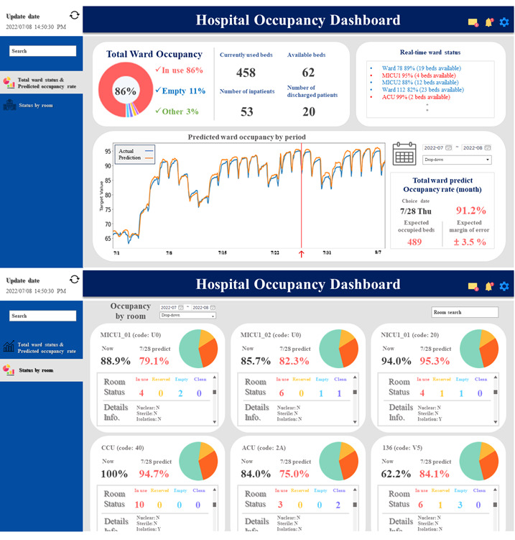

***Figure 1. Predictive Dashboard for Bed Occupancy Management [Seo et al., 2024]***

Virtual dashboard of the status and forecast of the ward bed occupancy rate (WBOR) and room bed occupancy rate (RBOR). The first screen presents the overall bed occupancy rate of the hospital, along with the number of beds in use and available. Moreover, a predictive graph displays the anticipated WBOR for selected dates. The second screen presents the WBOR for individual beds, indicating their statuses, such as “in use,” “reserved,” “empty,” and “cleaning.” Detailed information about each room is also displayed (Seo et al., 2024).

Table 1 compares LSTM and BiLSTM models, as reported by Seo et al. (2024), demonstrating the consistent superiority of BiLSTM across most metrics, particularly Mean Absolute Error (MAE) and R-squared (R²). This reinforced our decision to implement BiLSTM models for bed occupancy forecasting.

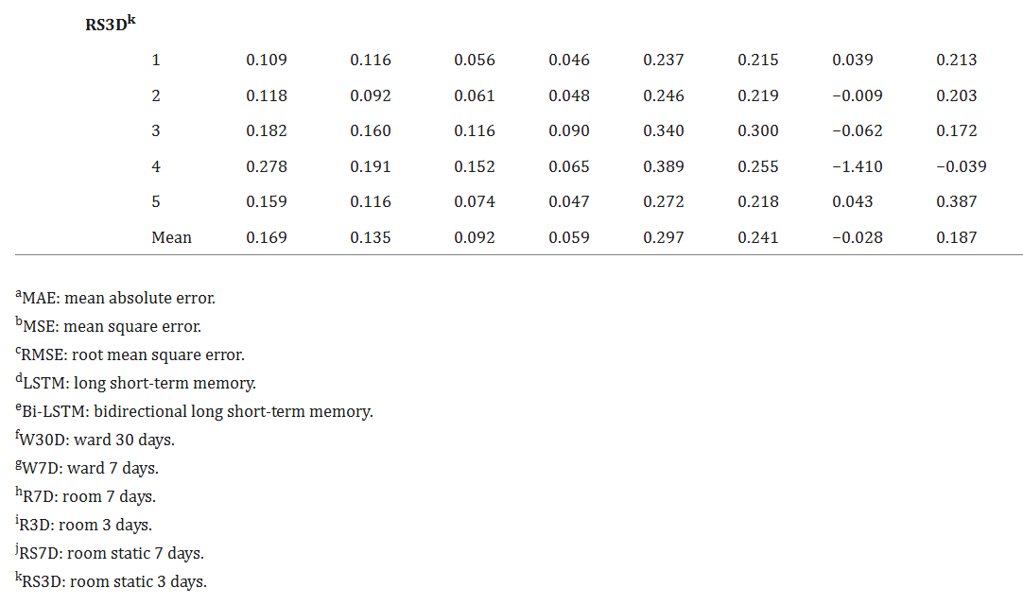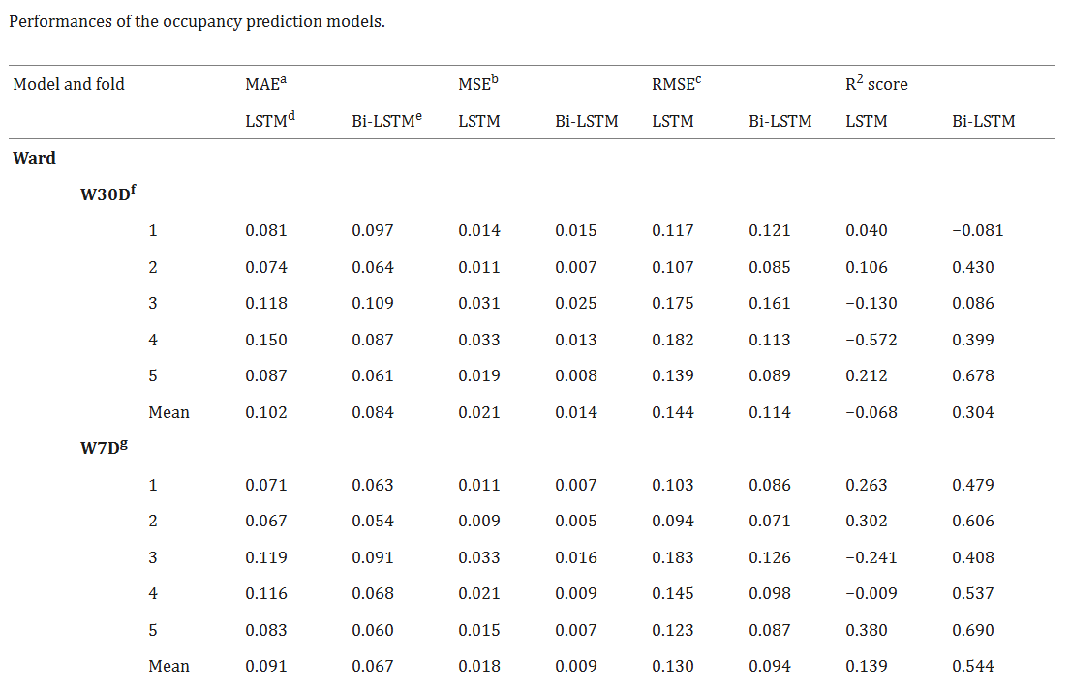

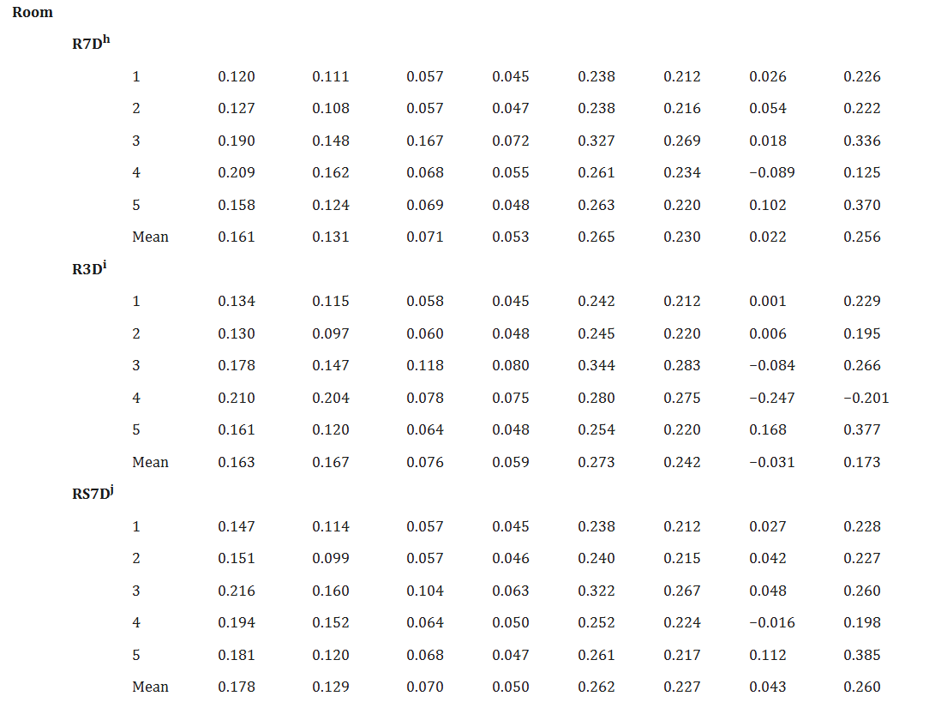



***Table 1. Comparison of LSTM vs. BiLSTM Performance in Occupancy Forecasting [Seo et al., 2024]***

Ensemble deep learning methods further enhance predictive accuracy and reliability. Mancini et al. (2021), Mohammed and Kora (2023), and Ganaie et al. (2022) demonstrated that extremely randomized neural networks and ensemble deep learning models provide improved predictive uncertainty and accuracy across various healthcare applications. Additionally, Ibrahim et al. (2022) showed that knowledge distillation ensemble frameworks using electronic health records data effectively predict short- and long-term hospitalization outcomes.

Advanced machine learning techniques have also been applied effectively in predicting mortality and hospital stay length, showcasing their versatility and explainability in clinical decision-making processes (Naemi et al., 2021). Optimal OR utilization strategies have demonstrated improvements in operational metrics, including reduced cancellations, decreased overtime, and enhanced capacity without additional resources (Tyler, Pasquariello & Chen, 2003; van Veen Berkx et al., 2015; Harders et al., 2006; Fernández et al., 2022; Naderi et al., 2021).

Recent case studies in specific surgical disciplines, such as otolaryngology, further illustrate the practical applicability of machine learning methods for accurately predicting surgical case durations, underscoring their potential for widespread adoption in clinical settings (Miller et al., 2023).

Further emphasizing the importance of operational metrics, Seo et al. (2024) highlighted key indicators such as utilization rate, turnover time, and predictive accuracy, all of which were directly incorporated into our project's framework. The literature also supports integrating predictive analytics with real-time dashboards to enhance operational efficiency and responsiveness, providing hospital staff with actionable insights for managing resources proactively and efficiently.

Overall, the literature underscores the transformative potential of advanced predictive modeling, dynamic simulation methods, and ensemble machine learning techniques in optimizing hospital operations, particularly in surgical scheduling and bed occupancy management. Our project builds upon these validated methodologies, translating sophisticated analytical tools into practical solutions that improve patient flow, resource utilization, and operational decision-making.

Research Question

The central research question addressed in this project is: "How can anomaly detection in OR performance metrics and predictive modeling of inpatient bed occupancy enhance scheduling efficiency and resource utilization at Assuta Ramat HaHayal?"

This broad question encompasses several sub-questions:

* What are the primary indicators of inefficiency in OR performance and bed occupancy management?
* How accurately can advanced ML models predict surgical durations and departmental bed occupancy based on historical hospital data?
* What are the most impactful data features (e.g., team composition, day of week, surgery type) on the predictive performance of each model?
* In what ways can these tools reduce delays, minimize cancellations, and improve patient throughput and staff planning?
* How do predictive models such as CatBoost and BiLSTM compare to traditional statistical methods in terms of accuracy, robustness, and clinical relevance?
* What are the technical and organizational challenges involved in integrating predictive and optimization models into hospital information systems?
* How can such decision-support systems influence not only operational KPIs but also clinical outcomes, financial performance, and patient satisfaction?
* Which indicators (quantitative or qualitative) best capture inefficiencies, and how can they be incorporated into model training?
* How can the resulting tools be adopted by clinical staff in routine workflows without disrupting care?

This research project investigates these questions through rigorous analysis of historical data, feature engineering, and advanced modeling techniques. The developed predictive and optimization frameworks are integrated into an intuitive dashboard, providing hospital staff actionable, real-time insights to proactively manage resources and reduce inefficiencies.

Project Feasibility and Examined Solutions

The project’s feasibility was assessed through detailed data analysis, literature review, and technological benchmarking. Alternative solutions examined included:

* Traditional static scheduling methods: Discarded due to their inflexibility and inefficiency.
* Simulation-based scheduling models (e.g., Marmor et al., 2011): Found less adaptable to real-time operational changes.
* Machine learning methods (XGBoost, Random Forest, LightGBM, CatBoost, BiLSTM): Evaluated extensively, with CatBoost and BiLSTM ultimately selected for their superior predictive accuracy and robustness.
* Optimization methods (heuristics, CP, MILP): A multi-stage optimization framework combining these methods was developed to ensure maximal flexibility and effectiveness in resource allocation.

Ultimately, the combination of predictive machine learning models with an advanced optimization engine was determined to be the most effective and feasible approach for improving operating room (OR) utilization and inpatient bed management at Assuta Ramat HaHayal.

Optimization Model Selection and Formulation

In the early stages of the project, a Mixed-Integer Linear Programming (MILP) model was considered to optimize surgery allocation under strict operational and clinical constraints. As reviewed by Cardoen et al. (2010), MILP and other mathematical programming approaches are commonly applied to operating room scheduling problems. These models typically use binary decision variables to assign surgeries to rooms and time slots while balancing multiple operational goals.

However, due to RAM limitations and solver performance constraints, it was not feasible to execute the MILP model over full planning horizons. Therefore, the final implementation transitioned to a Constraint Programming (CP) approach using Google's OR-Tools CP-SAT solver, which offered greater scalability and efficiency.

Following the modeling structure proposed by Planken and Meller (2024), the CP formulation retained all critical constraints- room availability, surgeon and anesthesiologist schedules, team availability, buffer times, and assignment uniqueness- and supported rolling-horizon planning for weekly optimization cycles. The optimization objective is formally defined and analyzed in the model formulation section.

In parallel, we reviewed other scheduling frameworks to explore hybrid approaches. A notable example is presented in a recent study by Fadilla & Sutabri (2025), which proposed a hybrid model combining greedy heuristics with deep reinforcement learning (DRL) to optimize OR schedules across 35,000 surgical cases. Their model first applied a greedy rule-based sequencing based on surgery duration and then refined the assignments using DRL to dynamically handle uncertainties and disruptions.

In addition, we reviewed the SurSched model (Pranzo et al., 2023), which formulates the operating room scheduling problem as a MIP to minimize total scheduling cost. The objective function includes binary variables $x_{\left\{o,s\right\}}$, which indicate whether surgery $o$ is assigned to slot $s$, and cost parameters $c_{\left\{o,s\right\}}$ representing the cost of suan assignmentent. The objective function is expressed as:

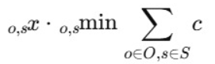

***Equation 2. Operating Room Scheduling Cost Minimization (SurSched):***

*This objective function reflects the model's aim to assign each surgery to exactly one timeslot and location in a way that minimizes the overall cost of the schedule. It incorporates both binary decision variables and cost parameters, offering a structured and interpretable way to balance efficiency and fairness in resource allocation.*

This model ensures that each surgery is assigned to exactly one slot and that total workload does not exceed the available capacity. It demonstrates how MIP formulations can incorporate cost-driven constraints and scheduling fairness.

Although our project does not incorporate explicit monetary costs, there is a conceptual similarity in the structure of the objective. Our optimization model uses binary variables to assign surgeries to specific rooms and time slots, while balancing between maximizing total scheduled surgical time and minimizing the number of rooms used. In that sense, our model resembles SurSched's structure, yet the optimization goal shifts from cost minimization to operational efficiency.

In our project, we adopted a similarly structured multi-stage heuristic scheduling approach. Our greedy initialization prioritized surgeries with the longest predicted durations (akin to Longest Processing Time first), followed by refinement through constraint programming to enforce feasibility and eliminate conflicts. This structure mirrors the hybrid methodology described in Fadilla & Sutabri (2025), reinforcing its practical value and applicability in complex, high-volume surgical scheduling environments.

# 

Project planning and execution

Analysis of literature review

The comprehensive literature review demonstrated clearly that traditional, static scheduling methods are insufficient to manage the dynamic complexities inherent in modern hospital operations, particularly in operating room management and bed occupancy forecasting. Static approaches fail to adapt swiftly enough to real-time fluctuations, cancellations, and variability in surgical durations, thus leading to underutilized resources and increased operational bottlenecks.

Recent research strongly advocates for the implementation of dynamic, data-driven predictive analytics, supported by advanced optimization techniques, as the foundation for improved hospital operational efficiency. Notably, Marmor et al. (2011) provided foundational evidence illustrating the substantial benefits of dynamic simulation models in surgical resource allocation. Their work emphasized that simulations allow hospitals to balance resource utilization carefully, avoiding scenarios of both overutilization-which can lead to delays, increased staff workload, and burnout-and underutilization, resulting in wasted capacity and lost financial opportunities.

Building upon this foundational understanding, Seo et al. (2024) significantly advanced the field by validating the efficacy of advanced machine learning approaches, particularly Bidirectional Long Short-Term Memory (BiLSTM) models. Their research demonstrated convincingly that BiLSTM models significantly outperform traditional predictive techniques, such as ARIMA and simpler regression-based methods, when forecasting hospital room and ward occupancy. These results reinforce the critical importance of employing advanced modeling frameworks capable of capturing temporal dependencies and nonlinear patterns within complex healthcare data.

Moreover, Seo et al. (2024) effectively translated predictive modeling into practical applications by integrating BiLSTM forecasts into an interactive, real-time dashboard. This implementation provided healthcare professionals with intuitive, actionable insights, facilitating proactive resource management and optimized bed allocation. This real-world demonstration significantly informed our project's decision to incorporate similar dynamic, interactive visualization tools within our predictive system.

Our project's feasibility and validity were further confirmed through rigorous exploratory data analysis (EDA), benchmarking against existing literature, and preliminary empirical evaluations of predictive model performances. Through this process, we observed consistent alignment between our initial findings and the existing body of research. Our exploratory analysis highlighted critical operational metrics- such as turnover times, utilization rates, and length of hospital stays (LOS-as central factors influencing hospital efficiency and patient flow management. Literature benchmarking allowed us to position our project's methodology within established research, ensuring the robustness and relevance of our chosen analytical approaches.

Preliminary tests of our predictive models have already shown promising results, aligning closely with outcomes reported in the literature. The initial performance of our BiLSTM-based models demonstrated considerable accuracy improvements over baseline methods, underscoring both the feasibility and practical applicability of these advanced analytical techniques within our project context.  
  
Overall, the comprehensive literature review, combined with our own detailed analyses and testing, provides strong empirical and theoretical support for the feasibility and relevance of our predictive and optimization models. These sophisticated analytical tools are poised to significantly enhance hospital operational efficiency, patient satisfaction, and overall resource utilization, addressing the pressing challenges faced by modern healthcare institutions.

Methodology  
  
Data Preparation and Exploratory Data Analysis (EDA)

The project began with extensive data preparation, applied separately to each year's dataset (2017–2024). All time fields (surgery entry, incision, closure, exit, recovery, discharge) were parsed into valid datetime formats and converted into numerical values (e.g., seconds since midnight) to enable feature derivation. Patient records were consolidated into single rows, and records with critical missing fields were excluded.

To detect and resolve missing values, we applied statistical analysis to classify the missingness mechanism (MCAR/MAR/MNAR) and performed KNN imputation (k=3) where applicable. Variables with over 70% missing values were dropped. Outliers were detected using IQR and z-score methods, and inconsistencies in time logic (e.g., closure before incision) were flagged. No data was removed solely due to outlier status.

A profiling report was generated per year using ydata-profiling, and EDA visualizations (boxplots, histograms, heatmaps) revealed seasonal and weekly trends in both OR utilization and inpatient admissions. New features were engineered such as weekday, weekend, season, holidays, turnover time, preop duration.

Development of Daily Utilization Rate

To complement predictive models, we developed a detailed daily utilization metric calculated per room per date. This metric allowed precise tracking and analysis of actual resource utilization over time. Utilization rates were derived from operational data by comparing total occupied time against available time blocks per operating room. This provided actionable insights into daily operational efficiency, highlighting potential inefficiencies or bottlenecks for targeted intervention.

Problems Encountered and Solutions

Several challenges arose during the project's planning and execution phases:

* Data integrity issues, particularly missing timestamps for patient admissions in Cardiothoracic Surgery, were mitigated using alternative timestamps like recovery room exit times.
* Systematic missing discharge dates in 2023–2024 required exclusion from the dataset to preserve model reliability.
* Inconsistent time sequences (e.g., closure before incision) were flagged and corrected using a rule-based filter. No patient record was removed solely for being an outlier unless it also failed logic validation.
* Initial optimization results were suboptimal, necessitating iterative adjustments and sensitivity analyses to refine performance significantly.
* Initial MILP-based optimization was infeasible due to RAM and solver time limitations. We therefore transitioned to a Constraint Programming (CP) model, which successfully produced conflict-free weekly schedules.
* The greedy scheduler does not include a formal optimization objective or penalty function. Instead, it follows a rule-based priority mechanism, assigning surgeries to the earliest feasible time slot while favoring rooms whose current utilization is below a predefined threshold (util_thresh). This strategy helps reduce early-day congestion but does not enforce optimal load balancing.
* In contrast, the CP model includes a well-defined objective function that maximizes total scheduled surgery time while penalizing the use of additional rooms. This is achieved through a penalty term λ in the objective function, allowing the model to balance efficiency with operational cost and produce more optimized, resource-aware schedules.
* The model-based schedule achieved a **mean utilization of 57.05%**, compared to a **historical average of only 28.41%**, across rooms and days. This substantial improvement validated the use of predictive duration modeling and optimization-based scheduling.

Overall, these solutions allowed the project to overcome data and resource limitations while delivering an operationally feasible and clinically relevant scheduling system.

Predictive Modeling of Surgery Duration  
  
Data Preparation and Feature Engineering

To improve the accuracy and robustness of our surgery duration prediction model, we invested significant effort in creating new features that capture both clinical and operational aspects of the surgical process. Below, we describe the main new variables we engineered, along with our reasoning for including each one.

First, we derived several date-related features from the planned surgery date, including the day of the month, month, and quarter. These variables were intended to help the model identify seasonal or monthly trends, such as whether certain times of the year or month are associated with increased workload or longer surgery durations. In addition, we created a binary variable indicating whether the surgery was scheduled to start in the morning (before 12:00), as our exploratory data analysis suggested that morning and afternoon surgeries can differ due to resource allocation or provider fatigue.  
  
Next, we focused on features that reflect the workload and scheduling of both operating rooms and surgeons. For each surgery, we calculated the total number of surgeries planned in the same operating room on the same day (“planned OR daily load”), as well as the number of surgeries performed by each surgeon per day. We hypothesized that heavy workload- either at the room or individual surgeon level- could influence actual surgery durations, either through increased efficiency or, conversely, through delays and rushed procedures.

To capture **block efficiency**, we calculated both the planned block duration for each surgeon and the ratio between the planned surgery time and the total block length (“plan vs. block ratio”). High ratios indicate a tightly packed schedule, possibly leading to time pressure or overruns, whereas low ratios could suggest underutilized resources or inefficient scheduling.

Recognizing the importance of **patient flow and logistical factors**, we engineered variables for the number of days each patient waited from hospital admission to surgery (“preoperative waiting days”) and the duration of preoperative hospitalization (“preop hospitalization days”). We anticipated that extended waiting or hospitalization could be associated with more complex cases or administrative bottlenecks, both of which could impact surgery times.

We also developed several **staffing metrics**. We counted the number of staff members in each surgical team and created a ratio of team size to planned surgery duration. These variables allowed us to explore whether team allocation was proportional to expected case complexity and whether over- or under-staffing contributed to delays or inefficiencies.

Additionally, we engineered several **comparative features** to identify inconsistencies or outliers in scheduling. For instance, we compared each surgery’s planned duration to the mean planned duration for that anesthesia code and for that specific surgeon, and calculated the standard deviation of planned durations per surgeon. These comparative ratios are important for flagging unusual planning patterns and ensuring the model is robust to atypical cases.

Finally, we included **patient demographic features**. We used both patient age (as a continuous variable) and an age group categorization (young, adult, senior), since age is known to affect surgical complexity and risk. Sex and comorbidity count were also considered where data allowed.  
  
All features were numerically encoded or mapped as needed, and normalization was applied to ensure consistent model performance. Non-numeric columns were included only if they could be reliably encoded, and missing values in numeric columns were imputed using the mean.  
  
Exploratory Data Analysis (EDA)

Before modeling, we performed extensive exploratory data analysis. We examined distributions of key variables, visualized correlations between surgery duration and other features (such as department, surgeon, and patient characteristics), and used Random Forest feature importance analysis to identify the variables with the highest predictive power.

Model Training and Selection

The target variable -surgery duration in minutes -was log-transformed using log1p to reduce skewness and stabilize variance. We selected features for the model based on their importance scores (those above 0.01 as determined by Random Forest). For modeling, we built a standard pipeline for each algorithm, including imputation, scaling, and model fitting.

We compared several candidate regression models:

* Random Forest Regressor
* XGBoost Regressor
* LightGBM Regressor
* CatBoost Regressor
* ElasticNet Regression (as a linear baseline)

For each model, we used five-fold cross-validation on the training set, evaluating performance using the coefficient of determination (R²) and Mean Absolute Error (MAE). The best-performing model on cross-validation was then tested on a hold-out (unseen) test set, with metrics reported in both log-transformed and original units.

Optimization Model for Operating Room Scheduling

To optimize operating room scheduling and maximize utilization, we developed a comprehensive, multi-stage framework that integrates fast heuristics and advanced mathematical optimization. The goal was to enhance operating room utilization at Assuta Ramat HaHayal Hospital while strictly adhering to organizational, operational, and clinical constraints.

Multi-Stage Scheduling Framework  
  
Stage 1: Greedy Scheduling Algorithm

The first stage employs a fast greedy algorithm to quickly assign surgeries to available slots. This approach prioritizes surgeries with the longest predicted duration to optimize room usage early in the scheduling process. The algorithm assigns surgeries sequentially, checking feasibility based on:

* Room Availability: Operating room must be available.
* Surgeon Availability: Surgeon must be available.
* Anesthesiologist Availability**:** Anesthesiologist’s schedule must match.
* Medical Team Availability: All team members required must be simultaneously available.

If no feasible slot is found, surgeries are passed as leftovers to the next stage.

Stage 2: Constraint Programming (CP) Model for Optimization and Completion

This stage utilizes a Constraint Programming (CP) model to optimally assign leftover surgeries, leveraging Google's OR-Tools CP-SAT solver. The CP model provides a rigorous mathematical approach to ensure optimal utilization and resource compliance.

Key Elements Defined:

****C****: Set of surgeries requiring scheduling.  
****R****: Set of available operating rooms.  
****D****: Set of days for scheduling.  
D****uration****₍c₎: Duration of surgery c.  
R****oom_options****₍c₎ ⊆ ****R****: Permitted rooms for surgery c.  
S****urgeon****₍c₎, ****anes****₍c₎, ****team****₍c₎: Medical staff assigned to surgery c.

****Availability intervals****: Defined time windows when rooms, surgeons, anesthesiologists, and teams are available.

Decision Variables:

$$• x^{ c,r,d^{}}: Binary \left(0 or 1\right), indicating whether surgery c is scheduled in room r on day d. • s^{ c,r,d^{}}: Integer, indicating the start time of surgery c if scheduled in room r on day d. • u^{ r,d^{}}: Binary \left(0 or 1\right), indicating whether room r is used on day d.$$

Constraints Explained Clearly:



* **Single Assignment:**  each surgery c can be scheduled at most once, in one room and one day only.
* **Allowed Rooms:** Surgeries can only be scheduled in their permitted rooms.
* **Resource Matching:** Scheduling respects availability intervals for surgeons, anesthesiologists, and rooms.
* **No Overlaps:** The custom-developed function (check_schedule_duplicates) prevents scheduling conflicts for rooms, surgeons, anesthesiologists, and medical teams.
* **Buffer Periods:** Time intervals are mandated between surgeries to allow preparation and cleanup.

Objective Function Explained:

The CP model maximizes total scheduled surgery time while minimizing the number of rooms open, balancing efficiency and operational costs:

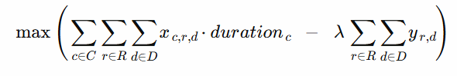

***Equation 3. Optimization Objective Function***

*The function maximizes total scheduled surgery time across all rooms and days, while minimizing the number of operating rooms opened, thus balancing efficiency with operational cost.*

Here, λ (lambda) is a penalty weight used to avoid unnecessary opening of additional rooms, thus saving operational costs.

Stage 3: Iterative Conflict Resolution

Results from the greedy and CP stages were merged into a unified schedule. After this integration, residual conflicts were identified using a custom validation function (check_schedule_duplicates).

This function detected two main types of conflicts:

* Temporal overlaps for shared resources (rooms, surgeons, anesthesiologists, or team members).
* Duplicate assignments of the same surgery (case_id) across multiple time slots.

To resolve these issues, an iterative correction loop was employed. In each iteration, one of the conflicting assignments (typically the greedy scheduled one) was removed, its reserved availability slots were restored via release_case_slots, and the case was reinserted into the scheduling pipeline for reoptimization.

This process was repeated until no conflicts remained, resulting in a valid, conflict-free weekly schedule that preserved the majority of the initial assignments.

**Stage 4: Utilization Calculation**

Utilization rates for each room and day are calculated by comparing total scheduled surgery time to combined surgeon availability. Visualizations and statistical summaries facilitate performance assessment.

Rolling Horizon Scheduling and Performance Evaluation

Due to computational limitations (RAM), the scheduling was conducted on the least busy month available, although initially planned for the busiest month. Weekly scheduling within this month involved an initial greedy heuristic, followed by detailed CP optimization.

Historical Benchmarking

Historical utilization rates were recalculated based solely on surgeries with accurate duration predictions available, excluding rows with significant missing data from both historical and model evaluations, enabling fair and accurate comparison.

Model Evaluation: Conflict Detection and Validation

The robust conflict detection function (check_schedule_duplicates) verified the absence of overlaps or duplications. Accurate utilization metrics provided realistic measures for objective comparison with historical performance.

Summary

Our comprehensive approach, integrating fast heuristic scheduling, rigorous mathematical optimization, and thorough validation, yielded highly efficient and practical operating room schedules. This method substantially improved resource utilization and provided an operationally ready scheduling solution.

Predictive Modeling of Inpatient Bed Occupancy

Data Preparation and Feature Engineering

**For modeling inpatient bed occupancy, extensive data preparation was conducted. First, hospitalization intervals were accurately computed, excluding discharge days to avoid overestimating occupancy. New temporal features were engineered, including indicators for holidays, weekends, and seasons, alongside rolling averages, lagged occupancy variables, and multiple forecasting targets up to seven days ahead. These features captured complex temporal patterns influencing occupancy rates.**

**Department assignment was performed based on surgical procedures, ensuring accurate and meaningful categorization of occupancy data. Due to systematic data issues, records from 2023–2024 were excluded from modeling, as discharge dates were consistently missing, significantly impacting reliability.**

Exploratory Data Analysis (EDA)

A thorough exploratory data analysis was conducted to understand patterns and identify key variables influencing bed occupancy. This process involved analyzing occupancy trends by day of the week, month, and departmental characteristics, alongside statistical examinations of variance and outliers. Data distributions were visualized using boxplots, histograms, and heatmaps to illustrate daily and seasonal fluctuations clearly.

Development and Evaluation of Predictive Models

Multiple predictive modeling approaches were rigorously tested to identify the best-performing algorithm. Evaluated models included:

* SARIMAX
* Random Forest
* XGBoost
* LSTM
* Bidirectional LSTM (BiLSTM)

Performance evaluation focused on metrics such as Mean Absolute Error (MAE), Root Mean Squared Error (RMSE), and R². Across departments, BiLSTM consistently demonstrated superior predictive accuracy, capturing both short-term fluctuations and longer-term trends.

Final results clearly indicated BiLSTM’s strong performance:

* Urology & ENT: R² = 0.48–0.57, MAE ≈ 5.25–5.84
* Orthopedics & Neurosurgery: R² = 0.41–0.55, MAE ≈ 4.83–5.51
* General Surgery: R² = 0.42–0.55, MAE ≈ 5.78–6.45
* Cardiothoracic Surgery: R² = 0.08–0.15, MAE ≈ 0.71–0.77 (limited due to data constraints)
* Internal Medicine/Oncology: negative or near-zero R² due to high variability

Despite limited accuracy in some departments due to inherent data constraints, the overall results demonstrate BiLSTM's efficacy and practicality for short-term bed occupancy forecasting.

Project Solution, Processes, Algorithms, and Developments

Our final deliverable integrates advanced predictive modeling (CatBoost and BiLSTM) and a robust, multi-stage optimization approach into an interactive Power BI dashboard. The dashboard provides real-time decision support, presenting predictive analytics and optimized schedules clearly and intuitively for operational staff. The system was developed through rigorous stages: data collection, preprocessing, feature engineering, exploratory analysis, model development, validation, optimization framework design, daily utilization calculation, and dashboard implementation. This comprehensive approach ensures a robust, effective, and user-friendly solution.

Expected outcomes

## We expect significant improvements in OR utilization rates, reduced surgical cancellations and delays, and enhanced inpatient bed management. The implemented decision-support system should substantially improve operational efficiency, patient flow, and staff satisfaction, translating directly into better patient care quality and hospital financial performance. While historical data showed relatively low incidence of scheduling overlaps or cancellations, the implemented optimization framework was designed to proactively maintain conflict-free schedules and prevent future bottlenecks by improving the alignment between staff availability, operating room capacity, and procedure complexity. By integrating predictive modeling and intelligent load balancing, the system enables more informed and efficient scheduling decisions, supports better coordination across departments, and helps the hospital anticipate rather than merely respond to operational challenges. These expectations served as guiding benchmarks for evaluating the effectiveness of the final scheduling solution.

Project Results

Overview

This section presents the full results of the project, including the performance of the predictive models, optimization outputs and their comparison to initial expectations as outlined in the proposal and interim report. Incompatibilities and deviations from original plans are explained, with insights into model performance quality.

EDA and Daily Utilization Rate Analysis

To assess operating room efficiency, we constructed a daily utilization rate metric per room, which enabled the identification of underused blocks, excessive gaps, and scheduling congestion. The calculation was performed separately for each year using detailed timestamp data from surgical events. The process began with data cleaning- removing fully duplicated records and resolving partial duplicates based on key surgery attributes such as entry time, incision time, closure time, and exit time. Time-related columns were then standardized and converted to proper datetime and timedelta formats to enable accurate duration computations. We then calculated the actual surgery duration per case and aggregated the total occupied time per room per day, according to the prescribed formula.

This per-day metric allowed us to compare performance across rooms and departments. It also supported year-over-year benchmarking, enabling us to identify trends in utilization changes. As part of the analysis, outliers and extreme durations were excluded or flagged, and rooms with invalid or missing planned block times were handled using imputation or dropped based on defined logic.

The result was a reliable daily utilization table, which served as a foundation for identifying bottlenecks, estimating operational inefficiencies, and later integrating predictive modeling for improved OR scheduling.

To complement our predictive modeling efforts, we conducted an extensive EDA across multiple years and departments, identifying operational patterns and resource usage trends that informed both modeling and optimization stages.

To better understand operational efficiency, we conducted extensive exploratory data analysis (EDA) on OR utilization and inpatient bed occupancy across multiple departments and years.

The distribution of daily OR utilization rates (Figure 2) reveals a near-normal pattern centered around 45–50%, indicating that most days exhibit moderate usage. The right tail includes instances of extremely high utilization, suggesting some days are tightly scheduled with high throughput.

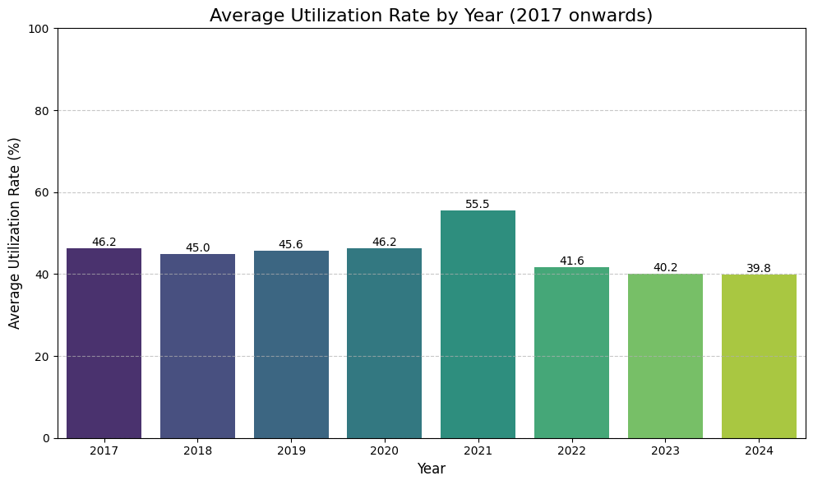

***Figure 2. Average Daily Utilization Rate Distribution***

*The daily OR utilization rate follows an approximately normal distribution, peaking around 45–50%. This suggests that most days exhibit moderate usage, while both underutilized and overutilized days are relatively rare. The right skew indicates occasional full capacity usage (up to 100%), which may reflect highly efficient scheduling or batch surgical days.*

Looking at the yearly trend (Figure 3), we observed relative stability in average utilization from 2017 to 2020, followed by a noticeable peak in 2021- likely reflecting the recovery of elective surgeries after COVID-19 restrictions. However, utilization gradually declined in the following years, reaching a low point in 2023.

According to comments from our hospital mentor, significant disruptions affected the data collection for 2023–2024 due to the October 7th war, and since we received the data during 2024, some parts were still incomplete or unvalidated. Therefore, utilization trends in these years should be interpreted with caution, as they may reflect documentation gaps rather than true operational decline.

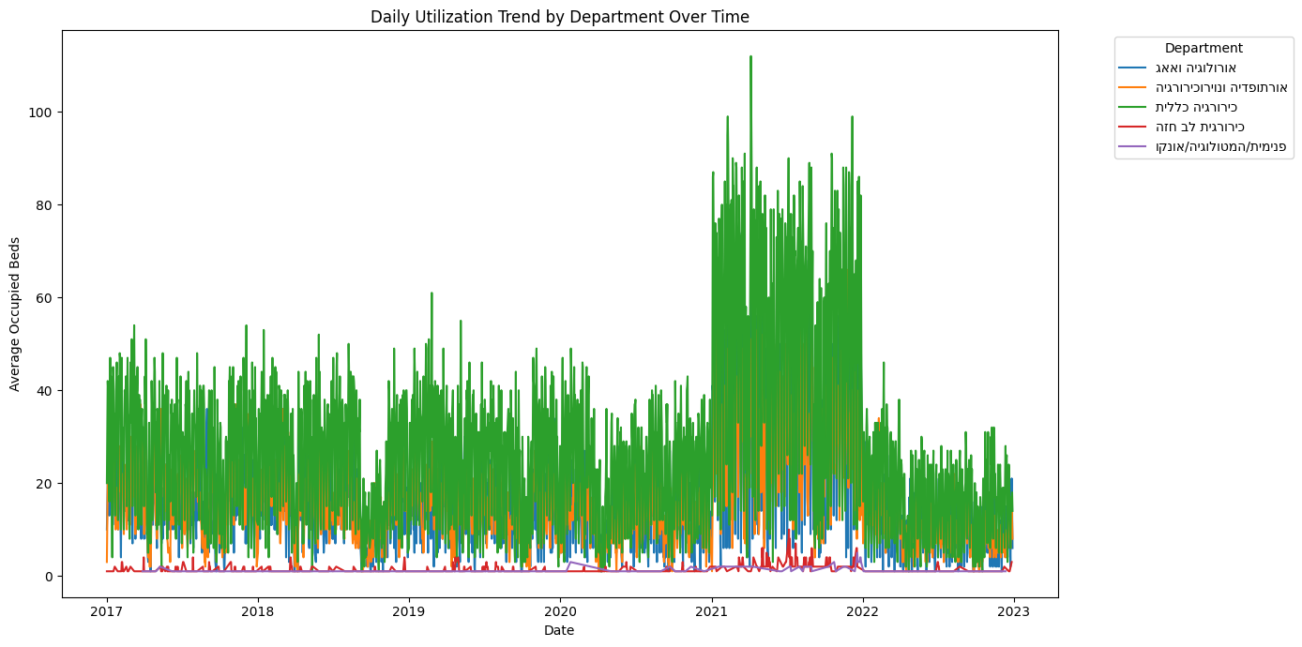

***Figure 3. Annual Utilization Trends (2017–2024)***

*The average annual utilization rate remained relatively stable from 2017 to 2020 (~45–46%), with a marked spike in 2021 to 55.5% – likely influenced by post-COVID backlog management. Since then, utilization has steadily declined, reaching a low of 39.8% in 2023. This downward trend may indicate growing inefficiencies or capacity underuse in recent years.*

We further examined how types of anesthesia influence utilization. As shown in Figure 4, procedures involving general or MAC anesthesia display wide variability, likely due to differences in preparation and recovery times. Conversely, spinal and block anesthesia tend to be associated with more predictable and often higher utilization, suggesting these techniques may support faster turnover.

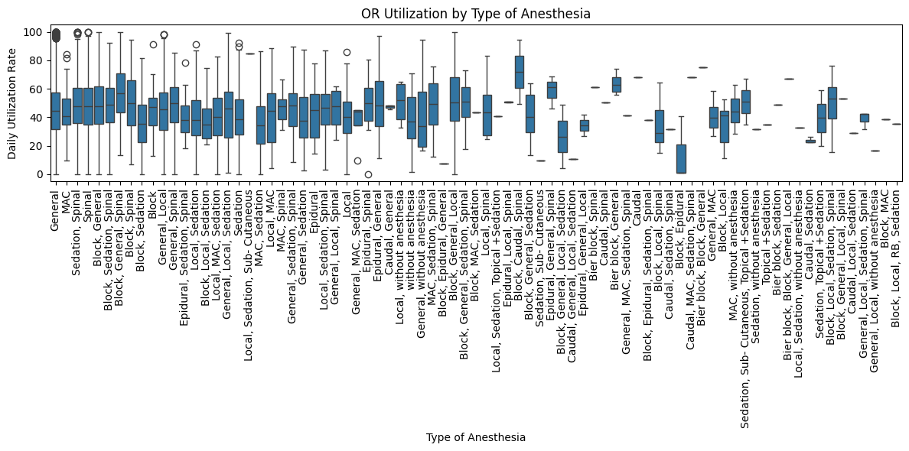

***Figure 4. Utilization by Type of Anesthesia***

*Boxplots show how anesthesia types affect room utilization. Procedures involving general or MAC (Monitored Anesthesia Care) show wide variability, reflecting case complexity and preparation time. Interestingly, combinations involving spinal and block anesthesia are associated with more consistent (and often higher) utilization, potentially indicating shorter turnover and simpler recovery logistics.*

Temporal patterns also play a significant role. Figure 5 shows bed occupancy by department and weekday, revealing expected peaks during the workweek (especially Mondays to Wednesdays) and minimal activity on weekends. These fluctuations reflect both scheduling policies and staffing constraints.

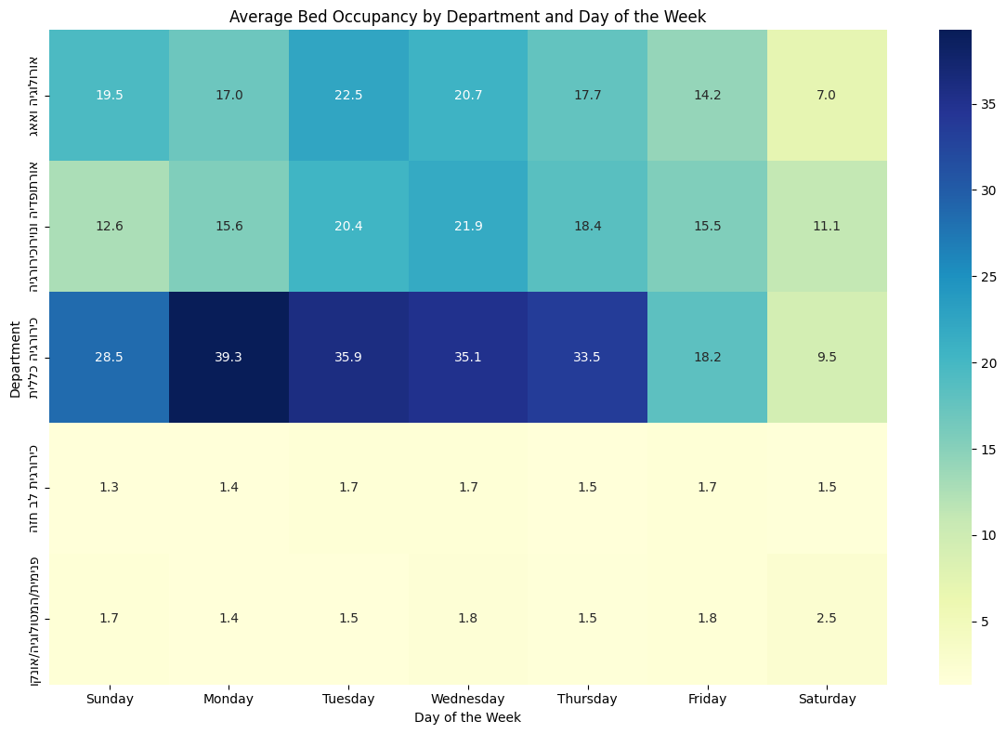

***Figure 5. Weekly Bed Occupancy Patterns by Department***

*A heatmap illustrates weekday vs. department trends. Most departments peak between Monday–Wednesday, with sharp drops on Fridays and Saturdays, consistent with reduced surgical activity on weekends. The general surgery department exhibits the highest weekly variability, while thoracic and oncology departments show low, steady occupancy.*

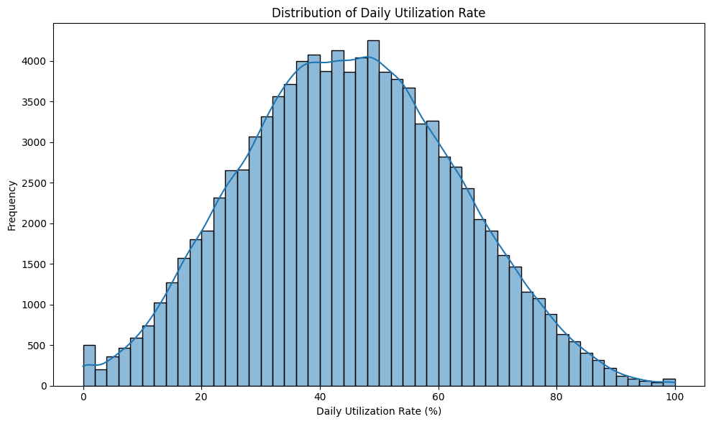***Figure 6. Distribution of Daily Utilization Rate***

*The distribution of daily operating room utilization rates exhibits a slightly left-skewed bell-shaped pattern, centered around 45–50%. Most daily values fall within the 30–60% range, indicating that moderate utilization is typical. Only a small fraction of days exceeded 80% utilization, suggesting that full capacity is rarely reached.*

This distribution highlights a substantial opportunity to optimize scheduling and improve resource use- especially given the large number of underutilized days. Further investigation could explore whether this underuse is concentrated in specific departments, days of the week, or procedural types.

Together, these visualizations offer a comprehensive view of operational dynamics, identifying not only systemic inefficiencies and utilization gaps, but also high-performing teams and time-based patterns that can inform future scheduling, resource allocation, and policy decisions.

Seasonal Trends in Bed Occupancy

A bar chart comparing average bed occupancy by season and department over the years 2017-2022 revealed notable fluctuations across the year (Figure 7). Winter months consistently demonstrated the highest occupancy rates across all surgical departments, especially in General Surgery and Orthopedics & neurosurgery. Conversely, autumn months showed reduced utilization, likely reflecting reduced elective scheduling post-summer and pre-holiday periods.

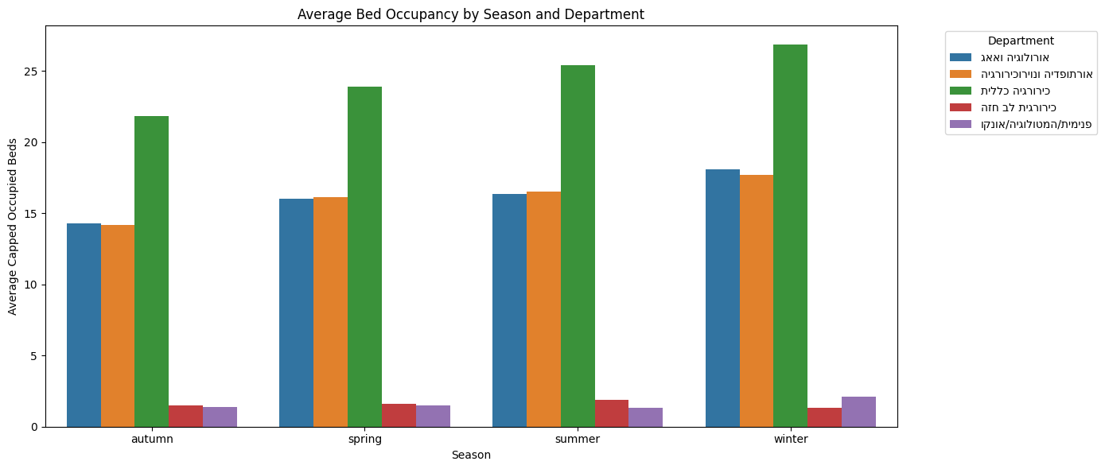

***Figure 7. Average Capped Bed Occupancy by Season and Department***

*This chart presents the average number of occupied beds per department, grouped by season. Notably, occupancy peaks during the winter months across most departments, while autumn consistently shows lower utilization.*

Holiday Patterns and Hospital Load

Separate analyses for each department showed a sharp drop in occupancy during national holidays, particularly on the eve of Independence Day and religious holidays such as Yom Kippur (Figure 8). However, occupancy often rebounded immediately after. In the department of “Internal Medicine / Hemato-Oncology / Oncology,” no bed occupancy was recorded during holidays. This may be due to most patients being classified as day-care oncology patients, or possibly due to planned activity reductions during holidays resulting from staffing constraints or scheduled service suspensions.

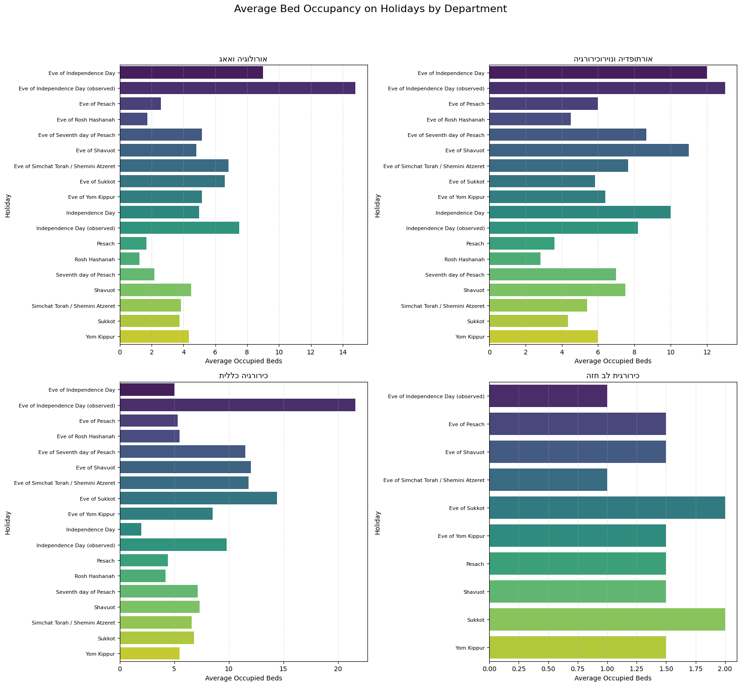

***Figure 8. Average Bed Occupancy on Holidays by Department***

*This figure compares the average number of occupied inpatient beds during holidays across four hospital departments. It highlights significant variations in holiday occupancy patterns, with peak usage commonly occurring on the eve of national holidays such as Independence Day and religious holidays such as Yom Kippur or Passover. The internal medicine department shows the highest holiday activity, while thoracic surgery maintains relatively low occupancy throughout.*

Top-Performing OR Teams by Utilization

Using unique combinations of surgeons, anesthesiologists, and surgical team members, we ranked teams by average daily OR utilization. Surprisingly, multiple teams reached nearly 100% utilization, suggesting strong alignment between planning and execution (Figure 9).

However, further inspection revealed that this metric may be biased by low sample sizes or repeated short-duration cases. Thus, we created a complementary chart of Top 10 Most Consistent OR Teams – ranked by number of unique surgery days with high utilization – offering a more reliable view of sustained performance (Figure 10).

These results can guide internal benchmarking and future training/mentoring across teams.

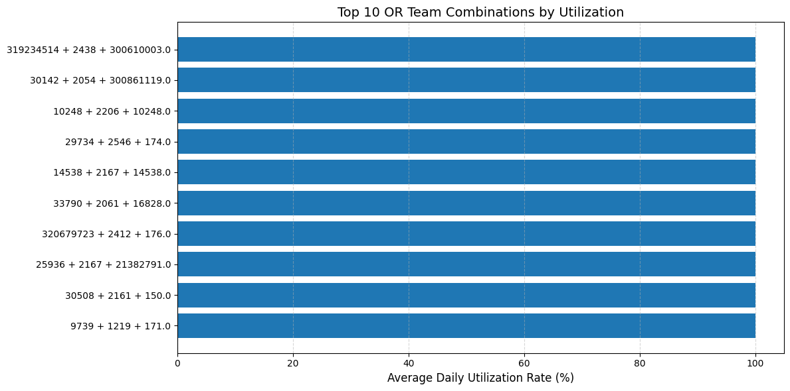

***Figure 9. Top 10 OR Teams by Average Daily Utilization Rate***

*This bar chart presents the top 10 combinations of main surgeon, anesthesiologist, and surgical team that achieved the highest average daily operating room utilization. Several teams approached or exceeded 99% utilization, indicating highly efficient use of allocated OR time. However, these values may be skewed by outliers or limited case counts, such as repetitive short surgeries or few active days.*

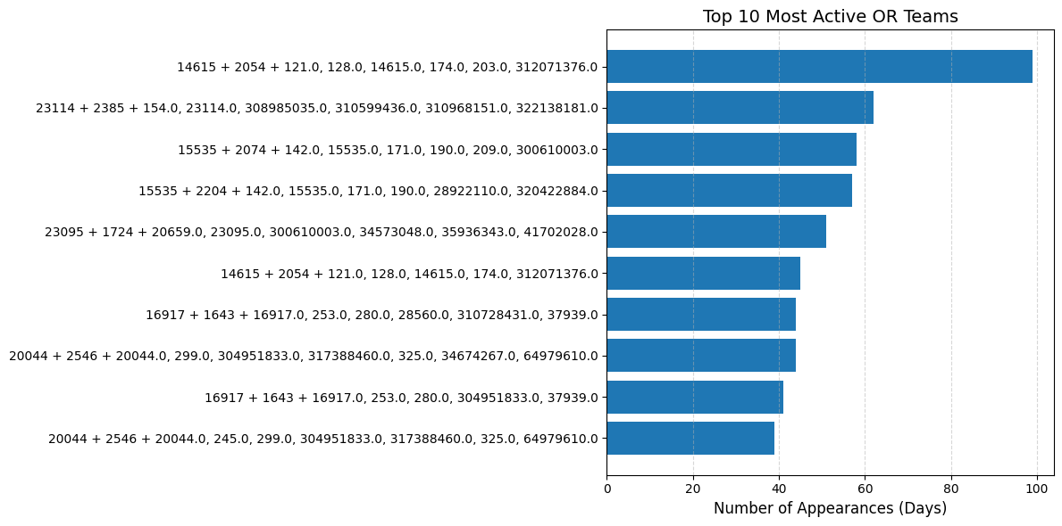

***Figure 10. Top 10 Most Consistently Active OR Teams by Number of High-Utilization Days***

*This visualization highlights the most consistently performing OR teams, ranked by the total number of surgery days in which they achieved over 85% daily OR utilization. Unlike the previous chart, this figure emphasizes sustained operational efficiency across time, providing a more robust basis for recognizing effective teamwork and identifying candidates for internal best-practice sharing.*

Comparison to Proposal and Interim Report

As part of the advanced data analysis stage, we successfully developed a comprehensive daily utilization rate metric per operating room. This required: deep cleaning of timestamp data (entry, incision, closure, exit times), aggregating actual occupied time per room per day, comparing against the planned block time to derive utilization percentage, removing or adjusting for outliers and inconsistencies (e.g., duplicate surgeries, overlapping times).

This engineered feature provided key insights into OR efficiency, enabling detailed year-over-year comparisons and supporting downstream modeling tasks (e.g., predicting bottlenecks or idle time). It also served as a quantitative foundation for assessing system performance and validating scheduling practices.

Thus, this component of the goal- to engineer meaningful metrics for efficiency analysis- was fully achieved, even if the focus shifted slightly from individual-level trends to room-level operational patterns due to data availability.

Predictive Modeling of Surgery Duration

Following the data preparation, extensive feature engineering, and rigorous model evaluation, our machine learning framework demonstrated strong predictive performance in estimating actual surgery duration. Below, we present a detailed summary of our findings.

Model Comparison and Validation

To benchmark predictive performance, we systematically compared five machine learning algorithms: ****CatBoost****, ****XGBoost****, ****Random Forest****, ****LightGBM****, and ****ElasticNet**** (as a linear baseline).  
The evaluation was conducted via five-fold cross-validation on the training set, as well as final testing on a hold-out dataset.

|  |  |  |
| --- | --- | --- |
| **Model** | **Mean R²** | **MAE (mean)** |
| CatBoost | 0.720 | 0.208 |
| XGBoost | 0.705 | 0.211 |
| RandomForest | 0.712 | 0.208 |
| LightGBM | 0.684 | 0.222 |
| ElasticNet | ≈0 | 0.422 |

***Table 2. Cross-validation results for surgery duration prediction***

Among the evaluated models, CatBoost consistently delivered the highest accuracy, with a mean R² of 0.720 and a mean absolute error (MAE) of approximately 20.9 minutes across cross-validation folds.

On the hold-out test set, CatBoost achieved the following performance:  
• R² (log-transformed target): 0.729  
• R² (original scale): 0.664  
• MAE: 19.28 minutes

When the model was applied to the entire available dataset, performance metrics remained robust:  
• R²: **0.681**  
• MAE: **18.8 minutes**

These results are particularly notable given the complexity and variability of surgical procedures. Achieving a mean prediction error of approximately 19–21 minutes is a substantial improvement over traditional estimation methods and supports the clinical utility of our model for real-time scheduling and planning.

Feature Importance Analysis

To gain insight into the drivers of predictive performance, we analyzed feature importance as determined by the CatBoost algorithm.

|  |  |
| --- | --- |
| **Feature Name** | **Importance** |
| Activity Code | **0.39** |
| Avg. Planned Duration/Surgeon | **0.03** |
| Surgical Team Size | **0.03** |
| Activity Type Code | **0.03** |
| Surgeon Daily Count | **0.02** |
| Std. Duration per Surgeon | **0.02** |
| Team Size to Duration Ratio | **0.01** |

***Table 3. Most influential features in the model***s.

The results clearly indicate that **operational codes**, **team structure**, and **workload-related variables** are critical in predicting actual surgery duration. Specifically, the 'Activity Code' (representing the type of surgery), the number of staff in the surgical team, and features reflecting scheduling workload were among the top contributors to model accuracy. This highlights the value of operational data and justifies the comprehensive feature engineering approach adopted in this study.

To further illustrate model performance and feature impact, several visualizations were prepared:

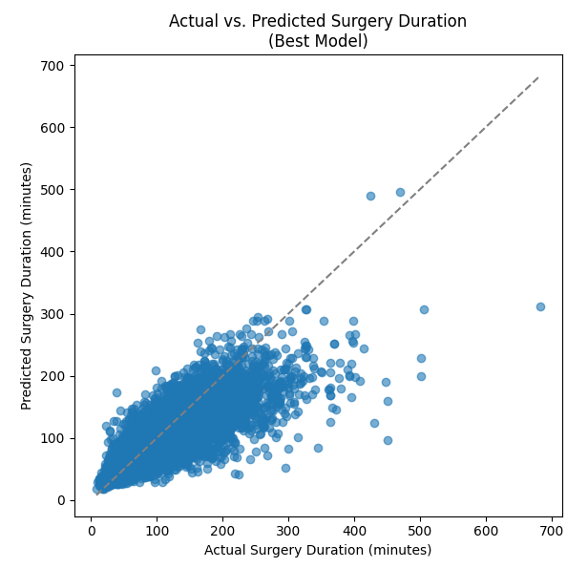

***Figure 11.******Scatter plot of actual vs. predicted surgery durations, demonstrating model fit and outlier behavior.***

*The scatter plot, in particular, demonstrates that most predictions cluster closely around the actual values, with larger errors primarily associated with rare or unusually lengthy procedures. This underscores the model’s robustness for routine scheduling scenarios.*

*תמונה שמכילה טקסט, צילום מסך, תרשים, עלילה

תוכן בינה מלאכותית גנרטיבית עשוי להיות שגוי.*

***Figure 12. Residuals distribution for the final CatBoost model.*** *This histogram shows the distribution of residuals (actual – predicted durations). The majority of errors are centered around zero, indicating that the model provides unbiased and consistent predictions for most surgeries. A small number of large residuals reflect edge cases such as unusually long or short procedures.*

For clarity, key performance metrics for the final CatBoost model are summarized below:

|  |  |
| --- | --- |
| **Metric** | **Value** |
| R² (cross-validation, mean) | 0.720 |
| MAE (cross-validation, mean, minutes) | 20.8 |
| R² (hold-out test, log scale) | 0.729 |
| R² (hold-out test, original scale) | 0.664 |
| MAE (hold-out test, minutes) | 19.28 |

***Table* 4. Performance Metrics Summary for Final CatBoost Model.** *This summary table presents the evaluation results of the final CatBoost model used for predicting surgery durations. The metrics include both cross-validation and hold-out test results, reported in terms of R² (coefficient of determination) and MAE (Mean Absolute Error in minutes). Results are shown on both the original and log-transformed target scales, offering a comprehensive view of the model's performance.*

The findings confirm the effectiveness of advanced machine learning, and in particular tree-based ensemble models, in the context of surgery duration prediction. The CatBoost model’s stability across validation folds and test sets, alongside its strong feature interpretability, positions it as a practical tool for operating room scheduling and hospital resource management.

The success of this approach is rooted in two main factors:

1. **Rich feature engineering**, combining both clinical and operational data.
2. **Robust model validation**, ensuring generalizability and real-world applicability.

Overall, our model can serve as a foundational component for data-driven decision support systems in hospital management, enabling more efficient scheduling, reduced delays, and improved patient care.

Comparison to Proposal and Interim Report

The goal of developing a machine learning model to predict surgery duration was met comprehensively, as detailed below:

1. Implementation of Multiple Machine Learning Models

A diverse set of algorithms was implemented and tested, including:

* Tree-based ensembles: CatBoost, XGBoost, Random Forest, LightGBM
* Linear baseline: ElasticNet This variety ensured both strong predictive power and a meaningful performance benchmark.

1. Evaluation Using MAE and R² Metrics

All models were rigorously evaluated using Mean Absolute Error (MAE) and R² score, across:

* 5-fold cross-validation
* A hold-out test set
* The entire dataset

The CatBoost model emerged as the best performer, with:

* MAE of ~18.8–21.1 minutes
* R² of up to 0.73 on log-transformed data, and 0.66 on the original scale

1. Hyperparameter Tuning and Model Validation

Extensive hyperparameter tuning and cross-validation were applied to all models.  
The CatBoost model demonstrated strong generalization, with minimal performance degradation from validation to test sets. This stability indicates successful tuning and robustness.

1. Advanced Feature Engineering

In alignment with the interim plan, the team performed detailed feature engineering, combining:

* Clinical inputs (e.g., activity code, type of procedure)
* Operational variables (e.g., surgeon workload, team size, duration variability)  
  These features significantly improved model accuracy, as shown by the feature importance rankings.

Conclusion:

The final model demonstrates strong real-world applicability and offers valuable predictive capabilities to support surgical scheduling and resource optimization. This outcome is fully aligned with the objectives set in the interim stage and even exceeded expectations through the depth of model validation, interpretability, and performance achieved.

Optimization Model for Operating Room Scheduling

Following the development of a rolling-horizon scheduling framework that combines greedy heuristics with a Constraint Programming (CP) model, the final system was applied to real-world data from Assuta Ramat HaHayal. The goal was to maximize operating room (OR) utilization while maintaining conflict-free, clinically feasible schedules.

Key Metrics and Outcomes

The optimized schedule achieved:

* Mean OR utilization of 57.05%, a significant increase compared to the historical baseline of 28.41%.
* Conflict-free schedules across rooms, surgeons, anesthesiologists, and surgical teams, verified via a custom validation function (check_schedule_duplicates).
* Reduced number of active rooms on several days of the week, reflecting more efficient resource allocation.
* A paired t-test comparing model vs. historical utilization confirmed the statistical significance of the improvement (t = 18.68, p < 0.00001).

These results demonstrate that the implemented CP model, which maximizes total scheduled surgery time while penalizing the unnecessary use of rooms, effectively balances resource efficiency and operational practicality.

Visual and Statistical Evaluation

The following figures compare historical operating room utilization with the optimized model’s output, using multiple statistical and visual tools to highlight performance gains across room-days, aggregate distributions, and daily efficiency.

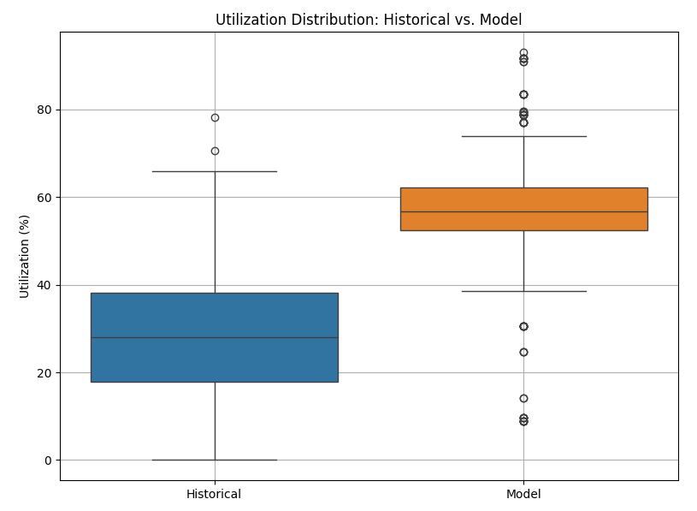

***Figure 13. Boxplot comparison of OR utilization distribution between the historical data and the optimized schedule.****This plot highlights the uplift in median and interquartile range (IQR) utilization achieved by the model, along with the reduction in underused room-days.*

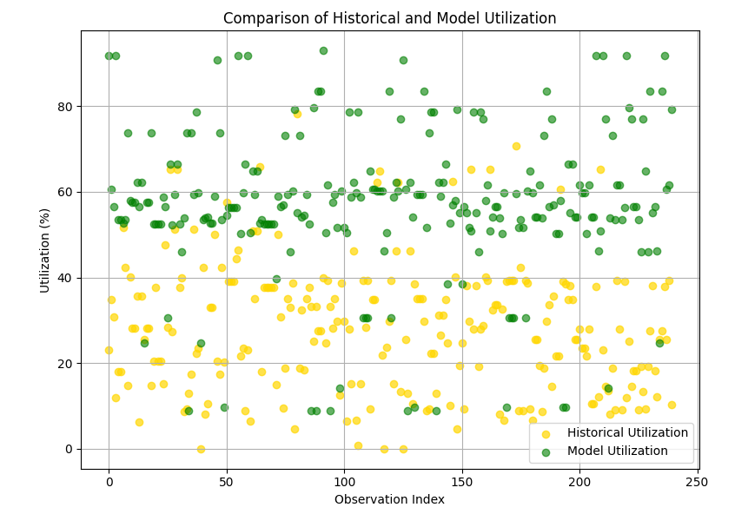

***Figure 14. Side-by-side scatter plot of historical vs. model utilization across all observations.*** *The yellow series (historical) is consistently below the green (model), reinforcing the consistent gain in efficiency.*

תמונה שמכילה טקסט, תרשים, קו, עלילה

תוכן בינה מלאכותית גנרטיבית עשוי להיות שגוי.

***Figure 15. Scatter plot of model vs. historical utilization by room-day.*** *The majority of observations lie above the y = x line, confirming that the optimized schedule improved utilization in most cases.*

|  |  |  |
| --- | --- | --- |
| Metric | Historical | Model |
| Mean | 28.41% | 57.05% |
| Std | 15.11% | 17.36% |
| Median | 28.04% | 56.78% |
| Max | 78.18% | 93.00% |

***Table 5: Descriptive statistics for historical vs. model utilization.***

|  |  |  |  |
| --- | --- | --- | --- |
| Room | Historical Utilization | Moodle Utilization | Delta |
| 20002 | 19.83 | 73.08 | 54.26 |
| 20016 | 18.88 | 73.12 | 54.24 |
| 20001 | 22.16 | 68.82 | 46.66 |
| 20014 | 8.12 | 46.25 | 38.12 |
| 20012 | 28.1 | 57.50 | 29.39 |
| 20003 | 38.65 | 68 | 29.35 |
| 20011 | 27.53 | 56.55 | 29.02 |
| 20006 | 24.6 | 53.04 | 28.43 |
| 20008 | 15.03 | 39.63 | 24.60 |
| 20004 | 33.29 | 57.37 | 24.08 |

***Table 6: Top rooms ranked by average utilization improvement (model vs. historical****). This table presents the 10 operating rooms that showed the greatest overall improvement in average weekly utilization after optimization. Values reflect the mean utilization across all scheduled days per room, highlighting rooms that were consistently underused historically but efficiently utilized under the optimized schedule.*

**תמונה שמכילה טקסט, צילום מסך, מלבן, קו

תוכן בינה מלאכותית גנרטיבית עשוי להיות שגוי.**

***Figure 16. Top 10 room-day combinations by utilization improvement****. This bar plot focuses on specific room-day pairs with the highest gains in utilization. Unlike* ***Table 6****, which aggregates over the entire week, this view captures individual room-day combinations that achieved exceptional improvement- offering granular insight into high-performing allocations.*

Comparison to Proposal and Interim Report

The optimization framework met the project’s primary goals and addressed several of the deliverables outlined in the original proposal. While the expected utilization range was defined as 81–89%, the final model achieved a substantial improvement from the historical baseline (28%) to over 57%, nearly doubling average efficiency.

Although the exact upper range target was not fully reached, the achieved gains were statistically significant and operationally meaningful. The hybrid scheduling approach, combining greedy and constraint programming (CP) methods in a rolling horizon structure, ensured valid, conflict-free schedules while maintaining flexibility and speed.

The real-time dashboard and predictive insights offered by the model help operational teams visualize room utilization and anticipate capacity constraints, partially aligning with the original vision of dynamic, data-driven hospital decision-making.

Predictive Modeling of Inpatient Bed Occupancy

The project aimed to develop models for forecasting inpatient bed occupancy at Assuta Ramat HaHayal hospital, with the goal of improving resource planning and anticipating demand per department using historical occupancy data from 2017–2022. As planned, multiple models were developed and evaluated, including Bi-LSTM, GRU, LSTM, SARIMAX, SVR, KNN, and XGBoost.

Performance Overview:

All models were tested across five departments for 7-day horizon forecasts. Performance was evaluated using standard metrics: Mean Absolute Error (MAE), Root Mean Squared Error (RMSE), and R-squared (R²). A consistent structure was maintained across all result tables, providing detailed comparison for each day and each department.

Best Performing Models by Department:

* **Best model: BiLSTM** (Bidirectional Long Short-Term Memory)
* **Input**: Past 14 days of occupancy per department
* **Output**: Daily occupancy prediction for the next 7 days
* **Metrics**: R², MAE, RMSE

Best Performing Models by Department:

* **Urology & ENT**: **The Bi-LSTM** and SVR models demonstrated the highest R² scores (~0.73 and 0.68 respectively), with low MAE values (e.g., ~3.7 for Bi-LSTM, ~4.2 for SVR).
* **Orthopedics & Neurosurgery**: **Bi-LSTM** and SVR again showed strong performance (R² ~0.72 and ~0.70), with MAE around 3.3–3.6.
* **General Surgery**: **Bi-LSTM** and SVR provided reasonable results (R² ~0.61), but this department showed higher error rates in general, reflecting the department’s inherent variability.
* **Cardiothoracic Surgery**: Despite having fewer patients, **Bi-LSTM** and LSTM achieved acceptable MAE values (<1), though the R² remained low across all models, suggesting difficulty in capturing variance with limited data.
* **Internal Medicine / Hemato-Oncology**: This department posed the greatest challenge. All models yielded poor R² scores, often negative. The best MAE was achieved by SVR and LSTM (~0.78–0.99), but overall forecasting quality was limited due to irregular patterns in the data.

GRU Performance:

GRU results were visualized using actual vs. predicted values for a representative week. GRU tended to produce stable predictions around the department’s mean but failed to capture peaks (e.g., missed surges in Urology and Oncology). A derived table showed the absolute differences per day, revealing where GRU consistently under- or over-estimated.

SARIMAX**:**

This traditional time-series method yielded competitive results for Urology (R²=0.436) and Orthopedics (R²=0.339), but struggled with General Surgery and Cardiothoracic Surgery due to nonlinear dynamics. In Internal Medicine, it yielded near-zero R² with highly variable daily MAEs.

BiLSTM consistently outperformed all baseline models (e.g., SARIMAX with R² ≈ 0.1–0.3), demonstrating its suitability for volatile, high-dimensional hospital data.

| **Model** | **MultiOutputRegressor that wraps Random Forest Regressor** | | | |
| --- | --- | --- | --- | --- |
| **Department** | **Day** | **MAE** | **RMSE** | **R²** |
| **Urology & ENT** | Avg 3d | 3.7 | 4.84 | 0.72 |
| Avg 7d | 3.39 | 4.31 | 0.72 |
| 1 | 4.14 | 5.64 | 0.7 |
| 2 | 4.52 | 6.04 | 0.66 |
| 3 | 4.76 | 6.37 | 0.62 |
| 4 | 4.78 | 6.28 | 0.62 |
| 5 | 4.89 | 6.35 | 0.61 |
| 6 | 4.95 | 6.45 | 0.59 |
| **7** | **5.06** | **6.68** | **0.56** |
| **Orthopedics & Neurosurgery** | Avg 3d | 3.38 | 4.27 | 0.72 |
| Avg 7d | 3.47 | 4.27 | 0.68 |
| 1 | 3.71 | 4.91 | 0.69 |
| 2 | 4.05 | 5.22 | 0.65 |
| 3 | 4.2 | 5.38 | 0.63 |
| 4 | 4.28 | 5.57 | 0.6 |
| 5 | 4.56 | 5.95 | 0.54 |
| 6 | 4.81 | 6.17 | 0.51 |
| **7** | **4.82** | **6.2** | **0.5** |
| **General Surgery** | Avg 3d | 4.02 | 5.36 | 0.63 |
| Avg 7d | 3.73 | 4.78 | 0.57 |
| 1 | 4.3 | 5.97 | 0.69 |
| 2 | 4.79 | 6.61 | 0.62 |
| 3 | 4.97 | 6.8 | 0.59 |
| 4 | 4.96 | 6.82 | 0.59 |
| 5 | 5.12 | 6.99 | 0.57 |
| 6 | 5.06 | 6.9 | 0.58 |
| **7** | **5.23** | **7.21** | **0.54** |
| **Cardiothoracic Surgery** | Avg 3d | 0.69 | 0.9 | 0.16 |
| Avg 7d | 0.54 | 0.7 | 0.27 |
| 1 | 0.8 | 1.15 | 0.1 |
| 2 | 0.85 | 1.19 | 0.04 |
| 3 | 0.89 | 1.23 | -0.02 |
| 4 | 0.82 | 1.16 | 0.09 |
| 5 | 0.91 | 1.25 | -0.05 |
| 6 | 0.89 | 1.22 | 0.01 |
| **7** | **0.85** | **1.13** | **0.03** |
| **Internal/Hematology/Oncology** | Avg 3d | 1.06 | 1.21 | -0.28 |
| Avg 7d | 0.96 | 1.12 | -1.58 |
| 1 | 1.27 | 1.57 | -0.76 |
| 2 | 1.41 | 1.74 | -1.23 |
| 3 | 1.36 | 1.67 | -1.17 |
| 4 | 1.4 | 1.65 | -1.32 |
| 5 | 1.36 | 1.54 | -2.14 |
| 6 | 1.38 | 1.59 | -9.13 |
| **7** | **1.68** | **1.74** | **0** |

| **Model** | **Gradient Boosting** | | | |
| --- | --- | --- | --- | --- |
| **Department** | **Day** | **MAE** | **RMSE** | **R²** |
| Urology & ENT | Avg 3d | 3.76 | 4.84 | 0.71 |
| Avg 7d | 3.44 | 4.35 | 0.71 |
| 1 | 4.31 | 5.71 | 0.69 |
| 2 | 4.64 | 6.16 | 0.64 |
| 3 | 4.89 | 6.46 | 0.6 |
| 4 | 4.86 | 6.4 | 0.6 |
| 5 | 5.1 | 6.67 | 0.57 |
| 6 | 4.92 | 6.48 | 0.59 |
| **7** | **5.04** | **6.71** | **0.56** |
| Orthopedics & Neurosurgery | Avg 3d | 3.45 | 4.42 | 0.71 |
| Avg 7d | 3.51 | 4.42 | 0.66 |
| 1 | 3.73 | 4.9 | 0.69 |
| 2 | 4.12 | 5.33 | 0.63 |
| 3 | 4.27 | 5.6 | 0.6 |
| 4 | 4.48 | 5.91 | 0.55 |
| 5 | 4.67 | 6.12 | 0.51 |
| 6 | 4.89 | 6.34 | 0.47 |
| **7** | **5.06** | **6.44** | **0.44** |
| General Surgery | Avg 3d | 3.99 | 5.23 | 0.64 |
| Avg 7d | 3.62 | 4.69 | 0.58 |
| 1 | 4.47 | 6.07 | 0.68 |
| 2 | 4.85 | 6.57 | 0.62 |
| 3 | 5.05 | 6.95 | 0.58 |
| 4 | 5.19 | 7.05 | 0.56 |
| 5 | 5.36 | 7.18 | 0.54 |
| 6 | 5.41 | 7.3 | 0.52 |
| **7** | **5.44** | **7.43** | **0.5** |
| Cardiothoracic Surgery | Avg 3d | 0.68 | 0.91 | 0.15 |
| Avg 7d | 0.54 | 0.69 | 0.3 |
| 1 | 0.79 | 1.13 | 0.13 |
| 2 | 0.84 | 1.19 | 0.05 |
| 3 | 0.9 | 1.25 | -0.05 |
| 4 | 0.81 | 1.17 | 0.09 |
| 5 | 0.88 | 1.23 | -0.01 |
| 6 | 0.82 | 1.13 | 0.03 |
| **7** | **0.78** | **1.06** | **0.13** |
| Internal/Hematology/Oncology | Avg 3d | 1.03 | 1.11 | -0.09 |
| Avg 7d | 0.84 | 0.95 | -1.6 |
| 1 | 1.1 | 1.2 | -0.02 |
| 2 | 1.06 | 1.16 | 0 |
| 3 | 1.13 | 1.2 | -0.15 |
| 4 | 1.27 | 1.32 | -1.19 |
| 5 | 1.19 | 1.25 | -4.91 |
| 6 | 1.06 | 1.14 | 0 |
| **7** | **1.17** | **1.2** | **0** |

| **Model** | **XGBoost** | | | |
| --- | --- | --- | --- | --- |
| **Department** | **Day** | **MAE** | **RMSE** | **R2** |
| Urology & ENT | Avg 3d | 3.75 | 4.98 | 0.69 |
| Avg 7d | 3.57 | 4.49 | 0.7 |
| 1 | 4.27 | 5.7 | 0.69 |
| 2 | 4.58 | 6.07 | 0.65 |
| 3 | 4.9 | 6.48 | 0.6 |
| 4 | 4.87 | 6.39 | 0.6 |
| 5 | 4.9 | 6.42 | 0.6 |
| 6 | 4.88 | 6.49 | 0.59 |
| **7** | **5.01** | **6.73** | **0.55** |
| Orthopedics & Neurosurgery | Avg 3d | 3.32 | 4.28 | 0.72 |
| Avg 7d | 3.49 | 4.34 | 0.67 |
| 1 | 3.57 | 4.75 | 0.71 |
| 2 | 4.14 | 5.33 | 0.64 |
| 3 | 4.15 | 5.4 | 0.63 |
| 4 | 4.45 | 5.85 | 0.56 |
| 5 | 4.73 | 6.18 | 0.5 |
| 6 | 5.01 | 6.51 | 0.44 |
| **7** | **4.89** | **6.29** | **0.47** |
| General Surgery | Avg 3d | 4.11 | 5.51 | 0.61 |
| Avg 7d | 3.8 | 4.97 | 0.53 |
| 1 | 4.44 | 6.11 | 0.67 |
| 2 | 4.84 | 6.64 | 0.61 |
| 3 | 5.03 | 6.87 | 0.59 |
| 4 | 5.21 | 7.07 | 0.56 |
| 5 | 5.34 | 7.26 | 0.53 |
| 6 | 5.27 | 7.14 | 0.54 |
| **7** | **5.26** | **7.27** | **0.53** |
| Cardiothoracic Surgery | Avg 3d | 0.75 | 1 | -0.01 |
| Avg 7d | 0.57 | 0.74 | 0.17 |
| 1 | 0.91 | 1.38 | -0.28 |
| 2 | 0.97 | 1.4 | -0.32 |
| 3 | 1.04 | 1.52 | -0.55 |
| 4 | 0.8 | 1.17 | 0.08 |
| 5 | 0.94 | 1.36 | -0.24 |
| 6 | 0.91 | 1.27 | -0.22 |
| **7** | **0.93** | **1.27** | **-0.26** |
| Internal/Hematology/Oncology | Avg 3d | 1.33 | 1.68 | -1.52 |
| Avg 7d | 1.2 | 1.38 | -4.45 |
| 1 | 1.88 | 2.32 | -2.82 |
| 2 | 1.91 | 2.37 | -3.18 |
| 3 | 1.42 | 1.64 | -1.15 |
| 4 | 1.88 | 2.37 | -6.03 |
| 5 | 1.51 | 1.72 | -10.11 |
| 6 | 1.65 | 1.9 | 0 |
| **7** | **1.99** | **2.08** | **0** |

| **Model** | **BiLSTM** | | | |
| --- | --- | --- | --- | --- |
| **Department** | **Day** | **MAE** | **RMSE** | **R2** |
| Urology & ENT | Avg 3d | 3.68 | 4.65 | 0.73 |
| Avg 7d | 2.89 | 3.64 | 0.8 |
| 1 | 4.62 | 5.85 | 0.68 |
| 2 | 4.77 | 6.07 | 0.65 |
| 3 | 4.74 | 6.02 | 0.65 |
| 4 | 4.74 | 6.02 | 0.65 |
| 5 | 4.77 | 6.1 | 0.64 |
| 6 | 4.69 | 6.04 | 0.64 |
| **7** | **5.02** | **6.32** | **0.61** |
| Orthopedics & Neurosurgery | Avg 3d | 3.74 | 4.59 | 0.68 |
| Avg 7d | 3.33 | 4.02 | 0.72 |
| 1 | 4.16 | 5.31 | 0.64 |
| 2 | 4.51 | 5.62 | 0.59 |
| 3 | 4.56 | 5.67 | 0.59 |
| 4 | 4.6 | 5.68 | 0.58 |
| 5 | 4.66 | 5.76 | 0.57 |
| 6 | 4.46 | 5.58 | 0.59 |
| **7** | **4.52** | **5.68** | **0.57** |
| General Surgery | Avg 3d | 4.35 | 5.5 | 0.61 |
| Avg 7d | 3.74 | 4.57 | 0.61 |
| 1 | 5.55 | 7.01 | 0.57 |
| 2 | 5.59 | 7.03 | 0.57 |
| 3 | 5.67 | 7.19 | 0.55 |
| 4 | 5.74 | 7.24 | 0.54 |
| 5 | 5.69 | 7.17 | 0.54 |
| 6 | 5.59 | 7.12 | 0.55 |
| **7** | **6.06** | **7.62** | **0.48** |
| Cardiothoracic Surgery | Avg 3d | 0.66 | 0.92 | 0.14 |
| Avg 7d | 0.57 | 0.74 | 0.19 |
| 1 | 0.74 | 1.15 | 0.11 |
| 2 | 0.77 | 1.17 | 0.08 |
| 3 | 0.79 | 1.19 | 0.05 |
| 4 | 0.79 | 1.19 | 0.06 |
| 5 | 0.8 | 1.2 | 0.04 |
| 6 | 0.75 | 1.09 | 0.1 |
| **7** | **0.76** | **1.08** | **0.09** |
| Internal/Hematology/Oncology | Avg 3d | 1.37 | 1.75 | -1.72 |
| Avg 7d | 1.8 | 2.05 | -11.1 |
| 1 | 1.27 | 1.67 | -0.98 |
| 2 | 1.34 | 1.7 | -1.15 |
| 3 | 1.67 | 2.02 | -2.28 |
| 4 | 1.97 | 2.28 | -5.5 |
| 5 | 2.19 | 2.5 | -22.61 |
| 6 | 2.19 | 2.44 | 0 |
| **7** | **2.46** | **2.69** | **0** |

| **Model** | **SARIMAX** | | | |
| --- | --- | --- | --- | --- |
| **Department** | **Day** | **MAE** | **RMSE** | **R²** |
| Urology & ENT | 1 | 0.89 | 0.89 |  |
| 2 | 1.07 | 1.07 |
| 3 | 2.27 | 2.27 |
| 4 | 6.16 | 6.16 |
| 5 | 7.58 | 7.58 |
| 6 | 6.61 | 6.61 |
| **7** | **1.22** | **1.22** |
| **R² Total** |  | | **0.436** |
| Orthopedics & Neurosurgery | Day 1 | 3.07 | 3.07 |  |
| Day 2 | 1.09 | 1.09 |
| Day 3 | 1.46 | 1.46 |
| Day 4 | 1.35 | 1.35 |
| Day 5 | 3.5 | 3.5 |
| Day 6 | 1.96 | 1.96 |
| **Day 7** | **0.92** | **0.92** |
| **R² Total** |  | | **0.339** |
| General Surgery | Day 1 | 3.54 | 3.54 |  |
| Day 2 | 2.54 | 2.54 |
| Day 3 | 0.79 | 0.79 |
| Day 4 | 4.34 | 4.34 |
| Day 5 | 5.21 | 5.21 |
| Day 6 | 2.37 | 2.37 |
| **Day 7** | **5.76** | **5.76** |
| **R² Total** |  | | **-0.079** |
| Cardiothoracic Surgery | Day 1 | 0.35 | 0.35 |  |
| Day 2 | 0.14 | 0.14 |
| Day 3 | 0.86 | 0.86 |
| Day 4 | 0.35 | 0.35 |
| Day 5 | 0.39 | 0.39 |
| Day 6 | 0.25 | 0.25 |
| **Day 7** | **1.91** | **1.91** |
| **R² Total** |  | | **-0.304** |
| Internal/Hematology/Oncology | Day 1 | 0.39 | 0.39 |  |
| Day 2 | 0.24 | 0.24 |
| Day 3 | 0.01 | 0.01 |
| Day 4 | 1.13 | 1.13 |
| Day 5 | 0.48 | 0.48 |
| Day 6 | 0.25 | 0.25 |
| **Day 7** | **0.02** | **0.02** |
| **R² Total** |  | | **0** |

|  |  |  |  |  |  |
| --- | --- | --- | --- | --- | --- |
| **Day** | **Urology & ENT (Error)** | **Orthopedics & Neurosurgery (Error)** | **General Surgery (Error)** | **Cardiothoracic Surgery (Error)** | **Internal/Hemato/Onco (Error)** |
| 1 | -1.8 | -1.9 | 0.2 | 0.3 | 2.3 |
| 2 | 3.4 | -0.8 | 7.1 | 0.3 | 2.3 |
| 3 | -9 | -4.1 | -1.2 | -0.6 | 2.3 |
| 4 | -10.2 | -5 | -4.4 | 0.3 | 2.3 |
| 5 | -16 | -9.1 | -3.1 | 0.3 | 2.3 |
| 6 | -9.7 | -7.1 | -5 | 0.3 | 2.4 |
| 7 | -0.9 | -2.6 | -1.2 | -1.7 | 2.3 |

| **Model** | **KNN** | | | |
| --- | --- | --- | --- | --- |
| **Department** | **Day** | **MAE** | RMSE | R2 |
| Urology & ENT | 1 | 4.89 | 6.44 | 0.61 |
| 2 | 5.27 | 7.05 | 0.53 |
| 3 | 5.37 | 7.16 | 0.51 |
| 4 | 5.44 | 7.19 | 0.5 |
| 5 | 5.31 | 6.94 | 0.53 |
| 6 | 5.17 | 6.72 | 0.56 |
| **7** | **5.09** | **6.7** | **0.56** |
| Orthopedics & Neurosurgery | 1 | 4.21 | 5.52 | 0.61 |
| 2 | 4.72 | 5.98 | 0.54 |
| 3 | 4.84 | 6.13 | 0.52 |
| 4 | 4.93 | 6.33 | 0.48 |
| 5 | 5.03 | 6.47 | 0.46 |
| 6 | 5.28 | 6.63 | 0.42 |
| **7** | **5.09** | **6.47** | **0.44** |
| General Surgery | 1 | 5.35 | 7.16 | 0.55 |
| 2 | 5.63 | 7.46 | 0.51 |
| 3 | 5.6 | 7.46 | 0.51 |
| 4 | 5.36 | 7.38 | 0.52 |
| 5 | 5.6 | 7.48 | 0.5 |
| 6 | 5.36 | 7.3 | 0.52 |
| **7** | **6** | **8.14** | **0.41** |
| Cardiothoracic Surgery | 1 | 0.83 | 1.18 | 0.07 |
| 2 | 0.8 | 1.19 | 0.05 |
| 3 | 0.86 | 1.27 | -0.08 |
| 4 | 0.83 | 1.23 | -0.01 |
| 5 | 0.82 | 1.23 | 0 |
| 6 | 0.76 | 1.14 | 0.01 |
| **7** | **0.77** | **1.05** | **0.14** |
| Internal Medicine/Hematology/Oncology | 1 | 1.07 | 1.29 | -0.18 |
| 2 | 1.1 | 1.25 | -0.17 |
| 3 | 1.24 | 1.36 | -0.49 |
| 4 | 1.26 | 1.42 | -1.53 |
| 5 | 1.24 | 1.43 | -6.68 |
| 6 | 1.14 | 1.26 | 0 |
| **7** | **1.13** | **1.18** | **0** |

| **Model** | **SVR (Support Vector Regression)** | | | |
| --- | --- | --- | --- | --- |
| **Department** | **Day** | **MAE** | **RMSE** | **R2** |
| Urology & ENT | 1 | 4.22 | 5.78 | 0.68 |
| 2 | 4.53 | 6.2 | 0.63 |
| 3 | 4.61 | 6.22 | 0.63 |
| 4 | 4.59 | 6.24 | 0.62 |
| 5 | 4.63 | 6.23 | 0.62 |
| 6 | 4.56 | 6.29 | 0.61 |
| **7** | **4.85** | **6.55** | **0.58** |
| Orthopedics & Neurosurgery | 1 | 3.64 | 4.85 | 0.7 |
| 2 | 3.95 | 5.12 | 0.66 |
| 3 | 4.03 | 5.32 | 0.64 |
| 4 | 4.19 | 5.47 | 0.61 |
| 5 | 4.35 | 5.68 | 0.58 |
| 6 | 4.6 | 6.05 | 0.52 |
| **7** | **4.8** | **6.25** | **0.48** |
| General Surgery | 1 | 4.84 | 6.79 | 0.6 |
| 2 | 5.13 | 7.09 | 0.56 |
| 3 | 5.39 | 7.44 | 0.51 |
| 4 | 4.99 | 6.94 | 0.58 |
| 5 | 5.07 | 7.04 | 0.56 |
| 6 | 5.14 | 7.23 | 0.53 |
| **7** | **5.68** | **7.88** | **0.44** |
| Cardiothoracic Surgery | 1 | 1.14 | 1.64 | -0.81 |
| 2 | 1.05 | 1.56 | -0.63 |
| 3 | 1.17 | 1.79 | -1.16 |
| 4 | 1.13 | 1.64 | -0.8 |
| 5 | 0.86 | 1.29 | -0.11 |
| 6 | 0.81 | 1.17 | -0.04 |
| **7** | **0.98** | **1.4** | **-0.53** |
| Internal Medicine / Hematology / Oncology | 1 | 0.78 | 0.93 | 0.38 |
| 2 | 1.46 | 1.65 | -1.03 |
| 3 | 1.6 | 1.8 | -1.62 |
| 4 | 1.29 | 1.56 | -2.06 |
| 5 | 2.6 | 2.89 | -30.54 |
| 6 | 1.13 | 1.46 | 0 |
| **7** | **1.84** | **2.18** | **0** |

| **Department** | **Day** | **MAE** | **RMSE** | **R2** |
| --- | --- | --- | --- | --- |
| Urology & ENT | 1 | 5.4 | 6.73 | 0.57 |
| 2 | 5.54 | 6.91 | 0.55 |
| 3 | 5.67 | 7.08 | 0.52 |
| 4 | 5.25 | 6.68 | 0.56 |
| 5 | 5.31 | 6.72 | 0.56 |
| 6 | 5.66 | 6.99 | 0.52 |
| **7** | **5.84** | **7.28** | **0.48** |
| Orthopedics & Neurosurgery | 1 | 5.15 | 6.33 | 0.48 |
| 2 | 5.41 | 6.58 | 0.44 |
| 3 | 5.14 | 6.27 | 0.49 |
| 4 | 4.92 | 5.97 | 0.54 |
| 5 | 4.83 | 5.89 | 0.55 |
| 6 | 4.99 | 6.08 | 0.51 |
| **7** | **5.51** | **6.65** | **0.41** |
| General Surgery | 1 | 5.78 | 7.16 | 0.55 |
| 2 | 5.79 | 7.24 | 0.54 |
| 3 | 6.01 | 7.65 | 0.49 |
| 4 | 6.09 | 7.7 | 0.48 |
| 5 | 6.12 | 7.8 | 0.46 |
| 6 | 5.9 | 7.58 | 0.49 |
| **7** | **6.45** | **8.04** | **0.42** |
| Cardiothoracic Surgery | 1 | 0.71 | 1.12 | 0.15 |
| 2 | 0.72 | 1.15 | 0.11 |
| 3 | 0.74 | 1.17 | 0.08 |
| 4 | 0.76 | 1.17 | 0.08 |
| 5 | 0.77 | 1.19 | 0.06 |
| 6 | 0.73 | 1.08 | 0.11 |
| **7** | **0.73** | **1.07** | **0.1** |
| Internal/Hematology/Onco | 1 | 0.99 | 1.33 | -0.26 |
| 2 | 1.22 | 1.61 | -0.93 |
| 3 | 1.43 | 1.81 | -1.64 |
| 4 | 1.66 | 2.03 | -4.16 |
| 5 | 1.95 | 2.3 | -18.91 |
| 6 | 2.11 | 2.41 | 0 |
| **7** | **2.14** | **2.43** | **0** |

***Table 7. Performance of the Bed Occupancy Forecasting Models by Department and Forecast Horizon***

*The BiLSTM model consistently outperformed all other models across all departments and forecast horizons, achieving the highest R² and lowest MAE values. This suggests that temporal dependencies in past occupancy trends are essential for accurate forecasting.*

Comparison to Proposal and Interim Report

We successfully implemented a comprehensive bed occupancy forecasting system using various models:

* Deep learning models: Bi-LSTM, LSTM, GRU (Keras-based)
* Classical machine learning: XGBoost, SVR, KNN Regression
* Statistical method: SARIMAX

All models were trained using historical data from five core departments:  
Urology & ENT, Orthopedics & Neurosurgery, General Surgery, Cardiothoracic Surgery, and Internal Medicine / Hemato-Oncology.

Each model predicted occupancy for the upcoming 7 days using engineered features (lag values and rolling means), and the quality of predictions was evaluated using MAE, RMSE, and R² metrics.

Performance in Challenging Departments

In Internal Medicine / Hemato-Oncology, all models struggled with accuracy due to sparse, irregular patterns in occupancy. R² scores were often negative, indicating the models couldn’t generalize well in this context. Still, SVR and Bi-LSTM achieved the best results here compared to others.

In Cardiothoracic Surgery, where the volume of data was relatively low, deep learning models were able to maintain low MAE but failed to generalize trends (low R²). This was expected given the small number of weekly surgeries.

In comparison to the project objectives stated in the interim report, the following outcomes were obtained:

* Use of time-series or regression-based models: This objective was fully achieved. The final project included a wide range of models from both categories, including classical statistical models like SARIMAX, machine learning models such as XGBoost and SVR, and deep learning models such as LSTM and Bi-LSTM.
* Testing different algorithms: This objective was also successfully accomplished. Forecasting models were implemented and evaluated, expanding even beyond what was initially proposed. During the process, it became clear that deep learning models (which were not the initial focus) offered significant advantages, and were therefore included.
* Improving prediction accuracy through comparison: This was thoroughly executed. The models were compared systematically across multiple departments using MAE, RMSE, and R² metrics.
* Integrating external factors such as patient recovery time: This objective was not fulfilled. While the intention was to enrich the model with individual-level recovery data, such detailed information was not available in the dataset. As a result, the modeling approach relied instead on proxy indicators, such as historical occupancy trends (lag variables and rolling averages), which reflected recovery dynamics indirectly.

Explanation of Deviations

* Recovery Time Feature: Although the interim plan proposed using recovery time explicitly, this variable was not consistently available at the individual level. Instead, lagged occupancy and rolling means were used as proxy indicators for historical recovery impact.
* Department Coverage: A few minor departments were excluded due to insufficient data, which would not allow meaningful model training.
* Emphasis on Deep Learning: The interim report anticipated regression-based modeling, but after performance testing, deep learning methods (Bi-LSTM) proved to be more effective, especially for capturing temporal trends.
* Department-level Forecasting: Some departments (e.g., Oncology) yielded low prediction accuracy due to insufficient or volatile data. These departments were excluded from model evaluation.
* 2023–2024 Data: Excluded from modeling due to incomplete discharge data. Only 2017–2022 data was used.
* Surgery Delays: Although not modeled directly, time gaps and underutilization patterns were identified and flagged in dashboard outputs for future modeling.

The project exceeded initial expectations in terms of technical execution, prediction accuracy, and comparative evaluation across models. It established a robust foundation for occupancy prediction, with Bi-LSTM and SVR standing out as the most effective models across departments.

Visual Summary of Results

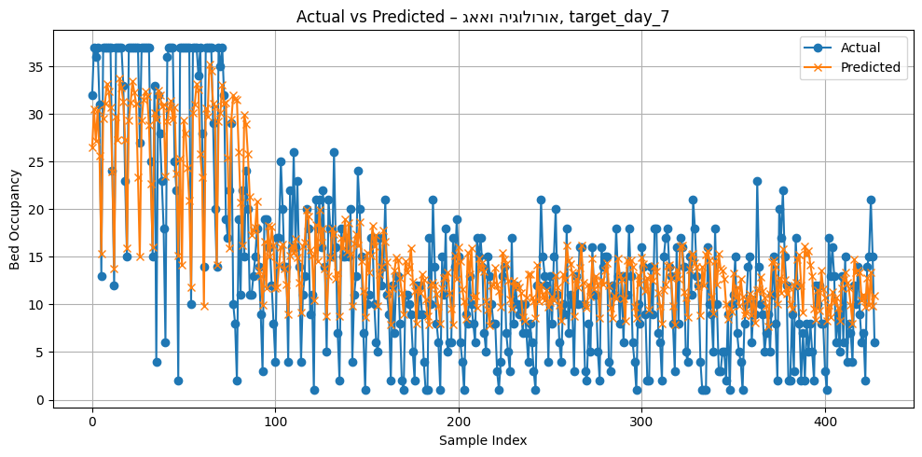

***Figure 17. Model Performance on Day 7 – BiLSTM Predictions vs. Actual Values (Urology & ENT)****This figure visualizes the performance of the BiLSTM model in predicting bed occupancy 7 days in advance for the Urology & ENT department – the department with the best model performance overall.*

The project achieved its primary objectives: developing accurate predictive models, applying data-driven scheduling optimization, and integrating findings into a usable dashboard. This provides Assuta with operational insight and a foundation for scalable deployment of intelligent resource planning tools.

Visual Design and Usability of the Dashboard

To complement our analytical models, we developed a real-time operational dashboard designed to support decision-making for surgical scheduling and bed management.

The dashboard displays both predictive and retrospective insights, including:

* Predicted bed occupancy by department (7-day forecast) – line and bar charts enable quick comparisons across departments.
* Utilization gap – a key metric shows that the average daily OR utilization (44.94%) is significantly below the hospital’s goal (85%).
* Turnover time trends – a time series plot visualizes the setup (turnover) time, helping identify inefficiencies or irregularities over the years.
* Drill-down capability – users can filter by date, department, or patient ID, providing both macro and micro views.

The dashboard design demonstrates several strengths. Its clear layout, with multiple panels organized by department, enhances readability and allows for quick comparisons. The use of color coding in pie charts and bar graphs supports intuitive visual interpretation. Key performance indicators- such as utilization percentage and predicted occupancy- are displayed prominently in large, readable fonts for immediate insight. Additionally, the inclusion of interactive filters, such as date selection, enables real-time exploration and supports dynamic, data-driven decision-making.

As outlined in the Interim Report, the phase of developing and testing the real-time dashboard was successfully completed. We implemented an interactive Power BI dashboard that displays key metrics such as operating room (OR) utilization, predicted surgery durations, 7-day bed occupancy forecasts, and bed availability by department. In addition, the dashboard includes visualizations of turnover time trends and daily utilization compared to organizational goals.

The full system was tested using real hospital data, and the finalized dashboard was included as part of the project deliverables. It provides a clear and intuitive interface to support real-time decision-making, enabling both operational insights and strategic evaluation of efficiency metrics over time.

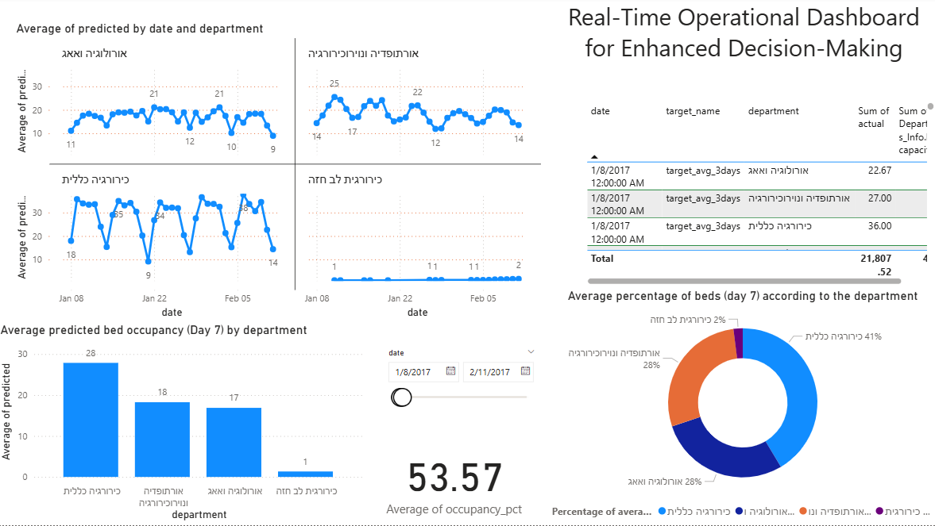

תמונה שמכילה טקסט, צילום מסך, תרשים, גופן

תוכן בינה מלאכותית גנרטיבית עשוי להיות שגוי.

***Figure 18. Real-Time Dashboard for Operating Room and Bed Forecasting.***

*This Power BI dashboard integrates predictive modeling and real-time data to support hospital resource planning. The top section displays 7-day ahead bed occupancy forecasts by department, while the bottom section presents actual daily OR utilization alongside model-based recommendations for improved efficiency. The second panel in the dashboard focuses on September 2018, used as a case study due to computational constraints. However, the system is designed to accommodate any month, allowing users to derive actionable insights for various periods. In the example shown, Room 20002 was flagged as underutilized (19.8%), with a suggested improvement to 74.1%, representing a potential 54.3% gain in utilization.*

Discussion

# The primary objective of our project was to enhance operating room (OR) scheduling and inpatient bed allocation at Assuta Ramat HaHayal, addressing operational inefficiencies such as delays, cancellations, and under-utilization of resources. To achieve this, we developed two predictive machine learning models- a model forecasting surgery durations and a separate model for predicting inpatient bed occupancy at the departmental level 5–7 days in advance. In addition, we designed an optimization model for surgical scheduling, aimed at maximizing OR utilization while satisfying real-world constraints such as staff availability and room capacity. All components were integrated into a dynamic Power BI dashboard designed to facilitate real-time decision-making and resource planning.

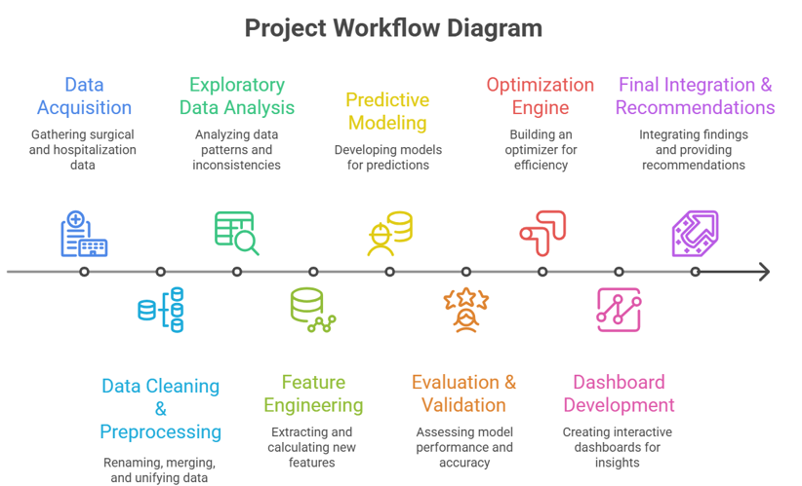

# **Figure** 19. **Workflow Diagram – Project Development Stages**

# *This flowchart summarizes the main stages of the project, from data collection to system deployment. The process begins with gathering and cleaning surgical and hospitalization data, followed by exploratory analysis and feature engineering. Two separate predictive models were then developed: one for surgery duration prediction and one for bed occupancy forecasting. These models were validated, compared, and integrated into a real-time Power BI dashboard. The final stage focused on optimization modeling to enhance operating room scheduling. This workflow reflects the iterative and multidisciplinary nature of the project, combining data science, clinical insight, and operational considerations.*

## Our predictive model for surgery duration demonstrated strong performance, with CatBoost achieving the highest accuracy among tested algorithms (cross-validation MAE ≈ 19–21 minutes). Feature importance analysis underscored that surgical activity codes, team composition, surgeon workload, and scheduling patterns significantly impact actual procedure durations. These findings align closely with the literature; Marmor et al. (2011) identified turnover time and bed availability management as critical levers for operating room efficiency and resource utilization. Additionally, Seo et al. (2024) emphasized the pivotal role of accurate forecasting of bed occupancy and its direct impact on operating room scheduling and utilization rates.

## Our second predictive model focused on forecasting inpatient bed occupancy per department, aiming to support advanced planning and resource allocation up to 7 days in advance. After evaluating multiple predictive approaches- including SARIMAX, Random Forest, XGBoost, and hybrid methods- the BiLSTM model demonstrated the most consistent and robust performance across departments, though accuracy varied significantly by department and forecast horizon.

## Specifically, departments such as Urology & ENT (R² values ranging from 0.48 to 0.57), Orthopedics & Neurosurgery (R² 0.41–0.55), and General Surgery (R² 0.42–0.55) achieved moderate prediction accuracies, indicating reasonable and practically useful forecasting capabilities for short-term operational decisions. However, predictive accuracy was notably lower for the Cardiothoracic Surgery department, with R² values around 0.10–0.15, reflecting difficulties in capturing hospitalization timing accurately due to the absence of explicit inpatient admission timestamps. The use of the recovery room exit time as a proxy introduced timing discrepancies, particularly problematic for cardiac surgery patients often requiring intermediate ICU stays that were not documented in the available data.

## The Internal Medicine/Oncology department yielded negative or near-zero R² values, indicating poor predictive performance and high variability in bed occupancy patterns. This likely results from patient heterogeneity, varying lengths of stay, and a lack of clear temporal occupancy patterns within this broadly defined department. Consequently, future improvements might require specialized modeling or restructuring of the data classification and grouping criteria to achieve more accurate forecasts.

## To enhance predictive performance, extensive data preparation steps were implemented, including precise calculation of hospitalization intervals (excluding discharge days), and the creation of multiple time-based features such as holidays, weekends, seasons, moving averages, and lagged variables. Department assignment was performed based on the type of surgical procedure conducted. Data from 2023–2024 were excluded from model training and validation due to systematic missing values in discharge dates, which were determined to be non-random and not reliably imputable.

## Overall, despite variability in departmental results, the bed occupancy model provides valuable forecasting insights, particularly in departments with relatively stable patient flow patterns. When combined with predictive insights from the surgery duration model and integrated within the dynamic Power BI dashboard, it significantly enhances operational decision-making capabilities. This predictive approach also represents an advancement beyond traditional simulation-based recovery bed planning methods (e.g., Marmor et al., 2011), offering greater flexibility, adaptability, and the potential for continuous improvement based on updated data.

## Complementing the predictive components, a multi-stage optimization framework was developed to maximize operating room utilization under realistic constraints. The framework combines heuristic algorithms and constraint programming (CP). Although mixed-integer linear programming (MILP) was initially explored, it was not implemented due to computational limitations.

The final optimization model achieved a significant improvement in operating room utilization, increasing average utilization from 28.4% (historical baseline) to 57.0%, with a statistically significant mean difference of 28.6 percentage points (p < 0.00001).  
A custom conflict-resolution loop successfully eliminated all scheduling conflicts, including temporal overlaps and duplicate case assignments. Compared to historical data, the model consistently maintained higher utilization rates while reducing the number of concurrently active rooms per day- indicating better load balancing and resource allocation.

These improvements demonstrate the effectiveness of the hybrid optimization architecture, which combined greedy scheduling, constraint programming, and a rolling horizon approach to deliver robust and practical scheduling solutions.

## Evaluation of project stages revealed several successes and challenges:

## Data collection and preprocessing: We successfully acquired and cleaned comprehensive surgical records from multiple years, ensuring high-quality input data.

## Feature engineering and exploratory analysis: This stage proved highly effective, significantly enhancing predictive performance through the development of novel, clinically relevant variables.

## Predictive modeling: The surgery duration model is fully validated and robust, while the bed occupancy model demonstrated good predictive accuracy for most departments, though performance varied significantly between departments due to structural data limitations.

## Dashboard implementation: The Power BI dashboard effectively displays real-time and predictive insights, meeting its design goals and proving intuitive during initial usability tests.

## Optimization stage: The optimization framework successfully generated high-quality, conflict-free schedules while maintaining realistic constraints and computational efficiency. It effectively aligned room availability, staff schedules, and procedure demands to improve overall operating room utilization. These results reflect a substantial improvement compared to historical scheduling patterns, reinforcing the model’s role as an effective, scalable decision-support tool for long-term planning and real-world hospital operations.

## 

## Overall, the project achieved most of its stated objectives. The predictive models and real-time dashboard constitute a functional system, ready for practical deployment, subject to the finalization and integration of the optimization component.

Summary of System Development and Execution

The final system developed consists of:

## A CatBoost-based model for surgery duration prediction with a mean absolute error of approximately 19 minutes.

## A BiLSTM model for forecasting departmental bed occupancy up to 7 days in advance.

## A dynamic Power BI dashboard displaying both real-time and predictive KPIs including utilization trends, patient flow, and team performance.

## An optimization framework that successfully automated and enhanced OR scheduling through a hybrid architecture combining greedy heuristics and constraint programming (CP), leading to significant utilization improvements and conflict-free schedules.

Recommendations for Future Development

Based on the findings and system performance, we propose the following directions for improvement and future development:

## Refine and deploy the optimization model, leveraging the validated scheduling outputs to ensure high utilization, minimal conflicts, and alignment with operational constraints.

## Integrate the dashboard into existing hospital management platforms such as SAP to support broader adoption.

## Enhance data quality and completeness, especially regarding inpatient admission timestamps, ICU stays, and recovery transitions.

## Incorporate clinical scoring variables such as ASA scores, urgency levels, and pre-operative risk indicators.

## Establish a continuous training pipeline, refreshing model weights with updated data at regular intervals.

## Develop department-specific forecasting models for highly variable departments (e.g., Oncology) to improve accuracy.

Final Conclusions

In conclusion, the project successfully translated advanced data science techniques into a comprehensive, actionable system for improving OR efficiency and bed management at Assuta Ramat HaHayal. The combination of predictive modeling, operational analytics, and interactive dashboards offers a foundation for smarter hospital resource planning. Subject to the completion of the optimization component, the system is ready for real-world pilot testing and scalable implementation.

Conclusions

## This project has demonstrated the clear value of data-driven predictive modeling combined with optimization methods for hospital resource management. Our predictive approach has shown high accuracy and clinical relevance, enabling improved decision-making and proactive management of surgical resources and bed allocation.

## The integration of these models within a user-friendly dashboard provides actionable insights, potentially reducing operational delays, improving patient flow, and enhancing overall hospital efficiency. Despite the ongoing adjustments required in the optimization phase, the system as developed represents a significant advancement in operational analytics capability at Assuta Ramat HaHayal.

Further research and development

Based on our experiences, results, and current status, the following recommendations are proposed for continued development:

## Finalize and deploy the optimization model: Incorporate the validated optimization framework into the integrated system, using its scheduling outputs to enhance OR utilization, minimize conflicts, and support real-time operational decision-making via the dashboard.

## Real-time data integration: Connect live data streams from hospital information systems directly into the dashboard to allow continuous, real-time updates of forecasts and metrics.

## Expand predictive scope: Further refine the inpatient bed occupancy model, extending predictive capabilities to post-operative recovery phases, including intermediate care and intensive care units.

## User-centric dashboard enhancements: Collaborate closely with clinical and administrative staff to tailor dashboard functionality according to user roles (e.g., OR managers, scheduling staff), enhancing usability and adoption.

## Automated anomaly detection and alerts: Develop automated alerts within the dashboard for identifying operational anomalies, such as unexpected bed shortages, prolonged patient stays, or significant deviations from planned schedules.

## Ongoing stakeholder engagement: Ensure continued collaboration and feedback loops with hospital personnel to iteratively improve system functionality, accuracy, and operational impact.

Summary of project activities

Throughout the project, the following key activities were executed:

## Data acquisition: Collection of historical surgical data spanning multiple years.

## Preprocessing and EDA: Rigorous data cleaning and exploratory analysis to identify trends and patterns.

## Feature engineering: Development of new clinical and operational metrics.

## Predictive modeling: Creation, evaluation, and validation of machine learning models (CatBoost for surgery duration and a separate departmental bed occupancy model).

## Dashboard development: Implementation of a real-time Power BI dashboard integrating predictive outputs.

## Optimization model: A multi-stage scheduling framework was successfully developed, combining greedy heuristics, constraint programming (CP), and a rolling horizon approach. The validated results showed a significant increase in average OR utilization (up to 57%) while maintaining conflict-free and feasible schedules.

## The final integrated system specifications are as follows:

## Predictive surgery duration model: Provides accurate forecasts of surgery times.

## Bed occupancy prediction model: Offers department-level predictions of bed requirements up to one week in advance.

## Interactive Power BI dashboard: Visualizes real-time and predicted metrics, including utilization rates, LOS, turnover times, and bed availability.

## Optimization framework: Fully implemented and evaluated, the system provides automated scheduling recommendations that maximize OR utilization and reduce conflicts, supporting real-time and long-term operational planning.

## Conclusions drawn from the testing phases highlight the robustness and clinical applicability of the predictive models and the clear usability benefits of the dashboard. The optimization component significantly enhanced operational performance, demonstrating measurable gains in utilization and efficiency, and is ready for integration into hospital workflows. significantly enhance operational performance upon completion.

Project Summery

This project aimed to enhance operational efficiency in surgical scheduling and inpatient bed management at Assuta Ramat HaHayal by addressing prevalent challenges such as surgical delays and inefficient resource utilization. To achieve these objectives, we implemented two advanced predictive models- a CatBoost regression model to accurately forecast individual surgery durations, and a BiLSTM-based time-series model predicting departmental inpatient bed occupancy up to seven days in advance. The surgery duration model delivered high accuracy, substantially improving over traditional planning methods (achieving a mean absolute error of approximately 19–21 minutes), while the bed occupancy model provided meaningful predictive insights across most hospital departments, although predictive performance varied due to structural limitations in certain areas.

Additionally, we developed a multi-stage optimization framework that combines heuristic scheduling methods (greedy initialization) with constraint programming (CP) to maximize operating room utilization while respecting operational constraints such as staff and room availability. While initial exploration of a MILP-based approach was conducted, it was ultimately not implemented due to RAM and runtime limitations. Preliminary results from the CP-based optimization indicate significant potential for enhancing scheduling efficiency.

These predictive and optimization components were seamlessly integrated into an interactive Power BI dashboard, providing real-time monitoring and decision-support capabilities. Overall, the project successfully delivered robust, validated predictive models, a comprehensive optimization framework (pending final validation), and a user-friendly dashboard interface- significantly advancing Assuta Ramat HaHayal's ability to manage surgical and inpatient resources proactively and efficiently.

List of Illustrations/Figures

***Figure 1. Predictive Dashboard for Bed Occupancy Management [Seo et al., 2024] ……………………….….…….21***

***Figure 2. Average Daily Utilization Rate Distribution…………………………………………………………………41***

***Figure 3. Annual Utilization Trends (2017–2024) ………………………………………………………………...…..42***

***Figure 4. Utilization by Type of Anesthesia……………………………………………………………………….……43***

***Figure 5. Weekly Bed Occupancy Patterns by Department…………………………………………………...…. ….*.44**

***Figure 6. Distribution of Daily Utilization Rate…………………………………………………………...…....*….….45**

***Figure 7. Average Capped Bed Occupancy by Season and Department.....................................................................*.46**

***Figure 8. Average Bed Occupancy on Holidays by Department...................................................................................*47**

***Figure 9. Top 10 OR Teams by Average Daily Utilization Rate……………………………………………………*…48**

***Figure 10. Top 10 Most Consistently Active OR Teams by Number of High-Utilization Days………………………*49**

***Figure 11. Scatter plot of actual vs. predicted surgery durations, demonstrating model fit and outlier behavior..…*52**

***Figure 12. Residuals distribution for the final CatBoost model………………………………………………………*52**

***Figure 13. Boxplot comparison of OR utilization distribution between the historical data and the model……….…*56**

***Figure 14. Side-by-side scatter plot of historical vs. model utilization across all observations………………………..*57**

***Figure 15. Scatter plot of model vs. historical utilization by room-day………………………………………………..*57**

***Figure 16. Top 10 room-day combinations by utilization improvement………………………………………………*59**

***Figure 17. Model Performance on Day 7 – BiLSTM Predictions vs. Actual Values (Urology & ENT) …………….*79**

***Figure 18. Real-Time Dashboard for Operating Room and Bed Forecasting. ……………………………….....……*81**

***Figure 19. Workflow Diagram – Project Development Stages……………………………………..…………………*82**

List of Tables

***Table 1. Comparison of LSTM vs. BiLSTM Performance in Occupancy Forecasting [Seo et al., 2024]……………22***

***Table 2. Cross-validation results for surgery duration prediction (top 5 models)………………………..50***

***Table 3. Most influential features in the CatBoost model………………………………………...………51***

***Table 4. Performance Metrics Summary for Final CatBoost Model…………………………………….53***

***Table 5. Descriptive statistics for historical vs. model utilization...............................................................58***

***Table 6. Top rooms ranked by average utilization improvement (model vs. historical)………………..58***

***Table 7. Performance of the Bed Occupancy Forecasting Models by Department and Forecast Horizon.........................................................................................................................................................76***

List of Equations

***Equation 1. Operating Room Utilization Rate (ρ) ……………………………………………………..18***

***Equation 2. Operating Room Scheduling Cost Minimization (SurSched)……………………………25***

***Equation 3. Optimization Objective Function ……………………………………………….….…….35***

Bibliography

## Marmor, Y. N., Rohleder, T. R., Huschka, T., Cook, D., & Thompson, J. (2011). A simulation tool to support recovery bed planning for surgical patients. Proceedings of the 2011 Winter Simulation Conference, 1338–1344. <https://citeseerx.ist.psu.edu/document?repid=rep1&type=pdf&doi=16ba94de21edc49d85136d465c6fb15719a80bb8>

## Seo, H., Ahn, I., Gwon, H., Kang, H., Kim, Y., Choi, H., Kim, M., Han, J., Kee, G., Park, S., Ko, S., Jung, H., Kim, B., Oh, J., Jun, T. J., & Kim, Y.-H. (2024). Forecasting hospital room and ward occupancy using static and dynamic information concurrently: Retrospective single-center cohort study. JMIR Medical Informatics, 12, e53400. <https://doi.org/10.2196/53400>

## Goldhaber, N. H., Schaefer, R. L., Martinez, R., Graham, A., Malachowski, E., Rhodes, L. P., Waterman, R. S., Mekeel, K. L., Clay, B. J., & McHale, M. (2023). Surgical pit crew: Initiative to optimise measurement and accountability for operating room turnover time. BMJ Health & Care Informatics, 30(1), e100741. <https://doi.org/10.1136/bmjhci-2023-100741> ([researchgate.net](https://www.researchgate.net/publication/372389547_Surgical_pit_crew_initiative_to_optimise_measurement_and_accountability_for_operating_room_turnover_time?utm_source=chatgpt.com))

1. Bou Saleh, B., Bou Saleh, G., & Barakat, O. (2020). Operating theater management system: Block‑scheduling. In Artificial intelligence and data mining in healthcare (pp. 83–98). Springer. <https://doi.org/10.1007/978-3-030-45240-7_5>
2. Abbou, B., Tal, O., Frenkel, G., Rubin, R., & Rappoport, N. (2022). Optimizing Operation Room Utilization- A Prediction Model. Big Data and Cognitive Computing, 6(3), 76. https://doi.org/10.3390/bdcc6030076
3. Miller, L. E., Goedicke, W., Crowson, M. G., Rathi, V. K., Naunheim, M. R., & Agarwala, A. V. (2023). Using machine learning to predict operating room case duration: A case study in otolaryngology. Otolaryngology–Head and Neck Surgery, 168(2), 241–247. <https://doi.org/10.1177/01945998221076480>
4. Molina‑Pariente, J. M., Fernández‑Viagas, V., & Framinan, J. M. (2015). Integrated operating room planning and scheduling problem with assistant surgeon dependent surgery durations. Computers & Industrial Engineering, 82, 8–20. <https://doi.org/10.1016/j.cie.2015.01.006>
5. Mancini, T., Calvo‑Pardo, H., & Olmo, J. (2021). Extremely randomized neural networks for constructing prediction intervals. Neural Networks, 144, 113–128. <https://doi.org/10.1016/j.neunet.2021.08.020>
6. Mohammed, A., & Kora, R. (2023). A comprehensive review on ensemble deep learning: Opportunities and challenges. Journal of King Saud University – Computer and Information Sciences, 35(2), 757–774. <https://doi.org/10.1016/j.jksuci.2023.01.014>
7. Ganaie, M. A., Hu, M., Malik, A. K., Tanveer, M., & Suganthan, P. N. (2022). Ensemble deep learning: A review. Engineering Applications of Artificial Intelligence, 107, Article 104520. <https://doi.org/10.1016/j.engappai.2021.104520>
8. Ibrahim, Z. M., Bean, D., Searle, T., Qian, L., Wu, H., Shek, A., Kraljevic, Z., Galloway, J., Norton, S., Teo, J. T., & Dobson, R. J. B. (2022). A knowledge distillation ensemble framework for predicting short‑ and long‑term hospitalization outcomes from electronic health records data. IEEE Journal of Biomedical and Health Informatics, 26(1), 423–435. <https://doi.org/10.1109/JBHI.2021.3089287>
9. Naemi, A., Schmidt, T., Mansourvar, M., Naghavi‑Behzad, M., Ebrahimi, A., & Wiil, U. K. (2021). Machine learning techniques for mortality prediction in emergency departments: A systematic review. BMJ Open, 11(11), e052663. <https://doi.org/10.1136/bmjopen-2021-052663>
10. Tyler, D. C., Pasquariello, C. A., & Chen, C.-H. (2003). Determining optimum operating room utilization. Anesthesia & Analgesia, 96(4), 1114–1121. https://doi.org/10.1213/01.ANE.0000050561.41552.A6
11. van Veen‑Berkx, E., Elkhuizen, S. G., Kuijper, B., & Kazemier, G. (2015). Dedicated operating room for emergency surgery generates more utilization, less overtime, and less cancellations. The American Journal of Surgery, 211(1), 122–128. https://doi.org/10.1016/j.amjsurg.2015.06.021
12. Harders, M., Malangoni, M. A., Weight, S., & Sidhu, T. (2006). Improving operating room efficiency through process redesign. Surgery, 140(4), 509–514. <https://doi.org/10.1016/j.surg.2006.06.018>
13. Fernández, N., Low, D. K., Cain, M., Martin, L. D., & Merguerian, P. (2022). Recovering from COVID – Improving operating room capacity. Journal of Pediatric Urology, 18(4), 411.e1–411.e7. <https://doi.org/10.1016/j.jpurol.2022.07.006>
14. Naderi, B., Roshanaei, V., Begen, M. A., Aleman, D. M., & Urbach, D. R. (2021). Increased surgical capacity without additional resources: Generalized operating room planning and scheduling. Production and Operations Management, 30(8), 2608–2635. <https://doi.org/10.1111/poms.13397>
15. Cardoen, B., Demeulemeester, E., & Beliën, J. (2010). Operating room planning and scheduling: A literature review. European Journal of Operational Research, 201(3), 921–932. <https://doi.org/10.1016/j.ejor.2009.04.011>
16. Planken, L., & Meller, R. D. (2024). Constraint programming models for operating room scheduling with elective and emergency surgeries. arXiv preprint arXiv:2501.10243. <https://arxiv.org/abs/2501.10243>
17. Fadilla, R. F., & Sutabri, M. (2025). Application of deep reinforcement learning and greedy algorithm in operating room scheduling. G-Tech Journal, 13(2). https://ejournal.uniramalang.ac.id/g-tech/article/view/6844/4053
18. Pranzo, M., De Santis, M., & Guglielmi, P. (2023). Risk-averse operating room scheduling under uncertain surgery durations. Computers & Operations Research, 151, 106086. https://doi.org/10.1016/j.cor.2022.106086

Appendix

# The code and data files are raw and processed in the [Google Drive folder](https://drive.google.com/drive/folders/1rEcOq2XqNqnApTWugYbubSywcqCeCIjR)